TRUMPET Pacetti Bay Jazz Cats Audition Material

Treble clef, 5-4 time, quarter note = 120
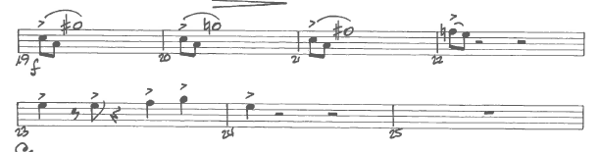

Treble clef, 4-4 time, quarter note = 120
