SAXOPHONE Pacetti Bay Jazz Cats Audition Material
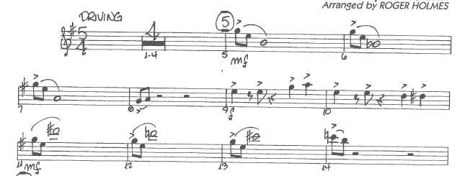

4-4 time, quarter note = 120
