PIANO Pacetti Bay Jazz Cats Audition Material
Quarter note = 120
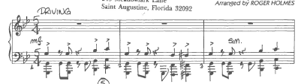

Quarter note = 120
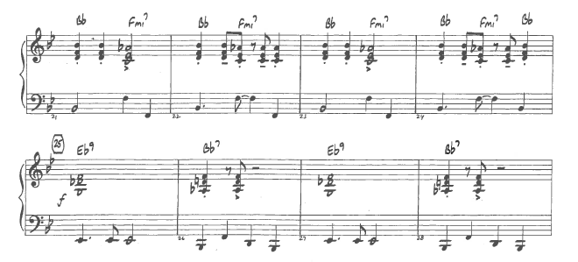Quarter note = 90
