Guitar Pacetti Bay Jazz Cats Audition Material

Treble clef, quarter note = 120, 5-4 time
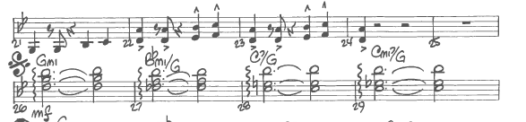

Quarter note = 120
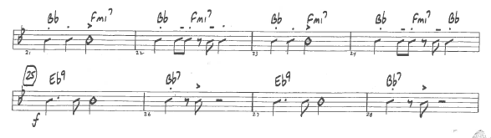

Quarter note = 90
