DRUMS Pacetti Bay Jazz Cats Audition Material
QUARTER NOTE = 120
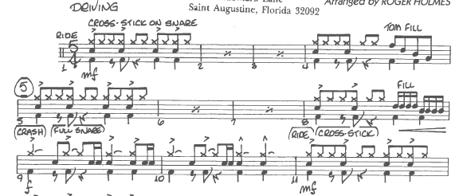
Quarter note = 120
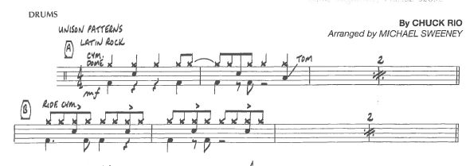
Quarter note = 90
