Bass Pacetti Bay Jazz Cats Audition Material
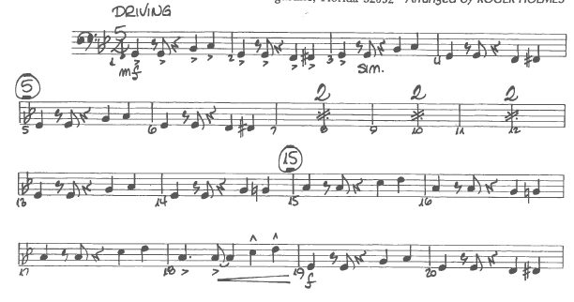
Bass clef, 4-4 time, quarter note = 120
