Private Lesson Teachers

Liz Deal – 703-7991 (Piano)

Brian Jenkins – 629-0728 (Drums)

Kathy Stephenson – 230-1185 (Piano)

Helen Salay – 540-0851 (Piano and music theory) St. Augustine area – Masters and very experienced helping students reach goals of jazz band, and even acceptance into a music major program at the university level.

Kenny Hamilton – 292-9705 – Kenny is a composer and performer as well as being proficient on 10 instruments; saxophone is his primary instrument.

Music and Arts Studio (S.R. 13 in Mandarin) – any instrument including voice.

Guitars United (S.R. 13 in Mandarin) – guitar lessons

Meghan,

Clarinet private lessons:  Linda Suppa 810-5995

**Piano:**



1. **Kathy Stephenson – 230 - 1185**
2. **Betty Atkinson – 262-1077**
3. **Liz Deal – 703- 7991 www.lizdealmusic.com**
4. **Nicole Loft – 231 – 2739 Clinger983@aol.com**
5. **Mary Conyers – 217-0028**
6. **Roger Ridente – 287-0425**

**Flute:**



1. **Kathe Isabelle – 287-6920**
2. **Donald Isabelle – 287-6920**
3. **Kathy Stephenson – 230 – 1185**
4. **Dean Slickis – (904) 333 - 4346**

**Reed Instruments:**

1. **Donald Isabelle – 287-6920**



1. **Leslie Blumenfeld – 287-2469**
2. **Dean Slickis – (904) 333-4346 (alto/ten. sax.)**
3. **Shirley Zielinski – 737-6064**
4. **Corey Peterson – 786-322-8752**

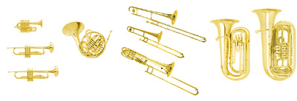**Brass Instruments:**

1. **Donald Isabelle – 287-6920**
2. **Rick Fowler – 547-7300 (ask for bandroom)**
3. **Roger Ridente – 287-0425 (trumpet only)**
4. **Martin Zielinski – 737-6064**
5. **Asa Jernagin – 230-3352**

**Percussion:**



1. **Alexander Hayward – 249 – 1136**
2. **Kevin Garry – 725-2236**
3. **Jon Farmer – 449-1742**

**String/Guitar and most band Instruments:**

1. **Schroeder’s School of Music – 230-4070**
2. 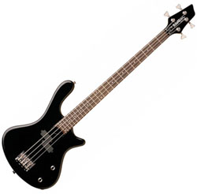**Music & Arts Centers– 292-9705**

