Crime Stoppers Student
Poster Competition 2024

Presented by:
R. J. Larizza, State Attorney
Crime Stoppers of NE Florida
Tim Forson, Superintendent St. Johns County Schools
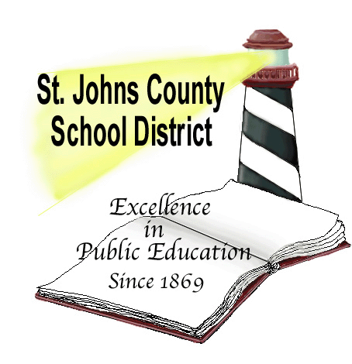
Sheriff Robert Hardwick, St. Johns County Sheriff
Entry Deadline: Thursday, April 18, 2024
Interoffice Mail: Joanne Crowder, Program Specialist, Secondary Curriculum and Instruction
Drop off posters to: Academic Support Annex, 405 Golfway West Drive, Suite 202
St Augustine, FL 32095

Theme: See It, Say It, Stop It
Use artwork and/or an original slogan that illustrates shared responsibility for student safety and conduct.
This is your contest and your voice matters.
Guidelines:

- Open to all students in grades K-12.
- Entries must be originals of the student artist. The use of copyright materials and/or designs is prohibited.
- Poster submissions should be no smaller than 8 ½ by 11 inches and no larger than 11 by 14 inches.
- Suggested mediums are as follows: crayon, ink, paint, markers, camera or digital media. All submissions must be two-dimensional.
- Keep with the positive theme. Do NOT include the Crime Stoppers logo.
- There are to be no images of guns, killing or drug paraphernalia in the art work. Adhere to the Student Code of Conduct and Dress Code.
- Please encourage students to use bright colors, which reproduce better then pastel colors.
- Attach the below entry form to the back of each student’s art submission. Entries without completed, attached forms will be disqualified. Print neatly.

Awards:

Cash awards will be presented to the 1st, 2nd and 3rd place winners in each division (Elementary, Middle and High) totaling in nine winners. The nine winners from Volusia, Flagler, Putnam and St. Johns Counties will then be judged on an overall circuit level. Each school division will have one overall winner.
$200- First Place $150 – Second Place $100 – Third Place

The three overall winners will receive
Name _________________________________Grade_____
School __________________________________________
Teacher__________________________________________
Home Address____________________________________
________________________________________________
Home Phone______________________________________
I acknowledge that the submitted work is original and is solely my work. I release my work for exhibition, photography, and reprinting as necessary.
Parents please indicate if you are comfortable with having your child’s name used in connection with their entry should they be a grand prize winner.

____ Yes, my child’s name can be used
____ No, please make sure my child remains anonymous

Student signature__________________________________
Parent signature____________________________________
an additional $500. Their posters will
be reprinted and placed in every
school in the four-county circuit,
at the appropriate grade levels.

Criteria for Judging:

- Adherence to the theme
- and contest guidelines
- Originality and Creativity
- Aesthetic Quality

