My Mission Statement: As an instructional literacy coach, it is my mission to act as an active member of the school learning environment by collaborating with and assisting teachers, parents, and students. I believe in child-centered teaching and will readily utilize data to drive the decision making process. I will model best teaching practices and communicate regularly with all stakeholders while maintaining a positive, organized learning environment. | 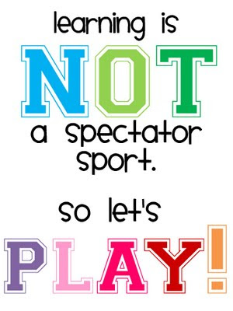  Be sure to visit my website at http://teachers.stjohns.k12.fl.us/rudi-c/ for links to testing, MTSS/RtI, and curriculum resources! |  | Menu of Instructional Coaching Opportunities  Mrs. Cristin Rudi, ILC  Picolata Crossing Elementary School

As your Instructional Literacy Coach, my primary purpose is to serve you and your precious students. It’s important that we work together as partners in trusting, respectful collegial relationships.
While iReady testing and MTSS/RtI will be a large part of my responsibilities at PCE, my heart is with you in your classrooms!
Here you will find a sampling of ideas for how you can utilize me throughout the school year. Of course, this is not an all-inclusive list so if you have further needs, do not hesitate to contact me.

By learning you will teach, by teaching you will learn.
--Latin Proverb

MONITOR
- Look at student work
- Monitor students during lesson and provide teacher with feedback
- Understand what assessment data is telling us
- Evaluate and interpret formal assessments
- Work with a coach to set up a system to monitor student progress
- Work with coach to create/monitor deliberate practice plan

ADJUST
- Receive feedback on an already planned unit or lesson
- Receive feedback on a lesson observed by the coach
- Work with a coach on differentiating a lesson
- Adjust instructional strategies after review of deliberate practice plan

PLAN
- Co-plan a differentiated lesson with coach
- Long-range planning using curriculum guides
- Lesson study (Working with a team to plan, observe, and modify lessons together)
- Work with the coach to make classroom environment appropriate for differentiation
- Receive help in finding appropriate resources
- Plan for differentiation of lessons to meet the needs of all students
- Plan MTSS/RtI interventions and gather materials

TEACH
- Observe the coach teach a lesson with focused post-dialogue
- Co-teach a lesson with the coach
- Watch a lesson in another classroom
- Lesson study
- Learn more about instructional strategies by reading, researching, watching

