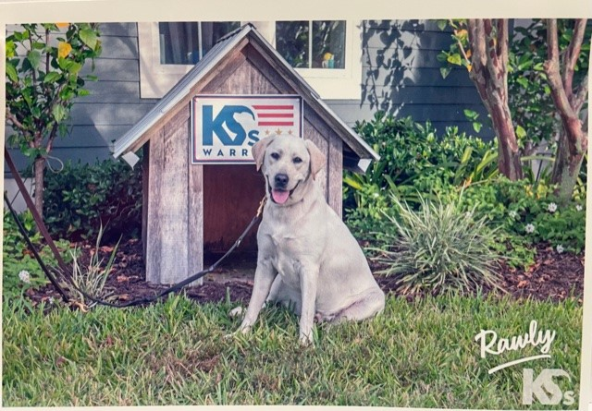

Rawly’s Graduation Auditions!

Dear 5th Grade Students,

You have a unique opportunity to take part in Rawly's graduation from K9s For Warriors. Rawly is expected to graduate at 5PM on Thursday, December 16th at the Shari Duval Campus located at 114 Camp K9s Road in Ponte Vedra (Nocatee area.)

Mrs. Suppa and Ms. Bettler are looking for a group of singers to sing and sign “America the Beautiful” prior to Rawly’s graduation, the evening of December 16th.

If you are interested in being considered for this special opportunity, please know that you will need to arrange transportation so that you can arrive at K9s by 4:30 PM on December 16th. Your parents will need to stay at graduation with you. Graduation ceremonies will conclude around 6:30 PM.

If selected, students are also committing to:
- Completing any classwork that they may miss due to practicing during school hours.
- Practicing sign language at home from a video that will be sent to them.

Please have a parent or guardian sign the below permission form and email a video of you singing “America the Beautiful.”

Email your videos to Mrs. Suppa and Ms. Bettler no later than Tuesday, November 30th.
Linda.Suppa@stjohns.k12.fl.us
Michelle.Bettler@stjohns.k12.fl.us

-------------------------------------------------------------------------------------------------
Please return this form to Ms. Bettler by Tuesday, November 30th

Student Commitment:
- Completing any classwork that they may miss due to practicing during school hours.
- Practicing sign language at home from a video that will be sent to them.
Student Signature _______________________________________________

Parent Commitment:
- Drive my child to K9s For Warriors on Thursday, December 16th with an arrival time of 4:30 PM.
- Remain at K9s during the duration of the graduation.
Parent Signature__________________________________________________

