Important Achieve Information

- Starting September 21, students will be required to complete two lessons on Achieve each week with a score of 75% or higher on the first attempt. The two lessons will be due every Thursday by 8:00 PM.

- Each lesson will be worth 5 points, for a total of 10 points each week. Please know that Achieve grades are entered as a weekly formative grade. Since this is a weekly grade, weekly Achieve lessons will have a significant impact on the overall grade.

- Students are responsible for monitoring their progress on their lessons.

Click on the “My Lessons” tab to locate Student Lessons

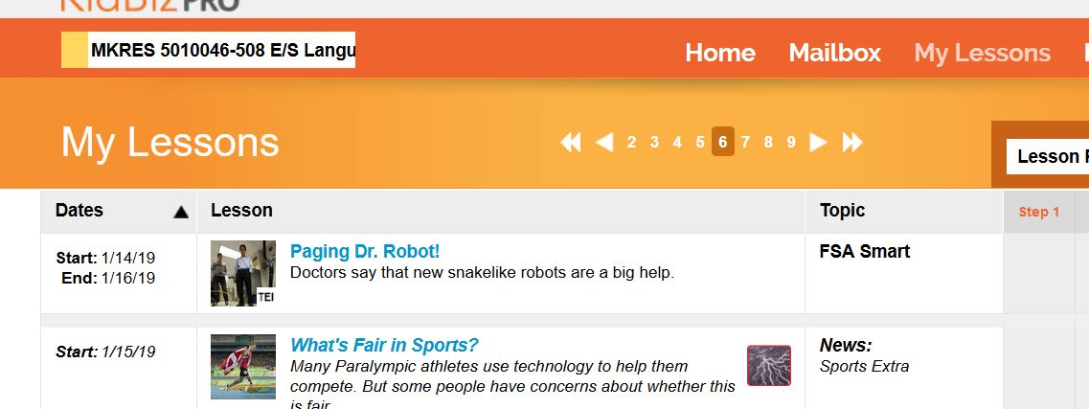

Click on Activity to review the scores

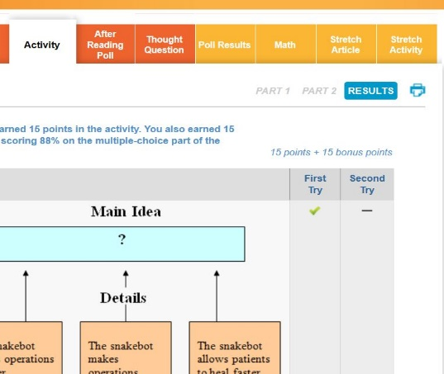

Scroll to the bottom to see the scores. Only scores of 75% or higher on both attempts will be accepted.
