34

THE INFLUENCE OF MONETARY AND FISCAL POLICY ON AGGREGATE DEMAND

WHAT’S NEW IN THE SIXTH EDITION:

There is a new In the News feature on “How Large is the Fiscal Policy Multiplier?” A new FYI on “The Zero Lower Bound” has also been added.

LEARNING OBJECTIVES:

By the end of this chapter, students should understand:

➢ the theory of liquidity preference as a short-run theory of the interest rate.

➢ how monetary policy affects interest rates and aggregate demand.

➢ how fiscal policy affects interest rates and aggregate demand.

➢ the debate over whether policymakers should try to stabilize the economy.

CONTEXT AND PURPOSE:

Chapter 21 is the second chapter in a three-chapter sequence that concentrates on short-run fluctuations in the economy around its long-term trend. In Chapter 20, the model of aggregate supply and aggregate demand is introduced. In Chapter 21, we see how the government’s monetary and fiscal policies affect aggregate demand. In Chapter 22, we will see some of the trade-offs between short-run and long-run objectives when we address the relationship between inflation and unemployment.
The purpose of Chapter 21 is to address the short-run effects of monetary and fiscal policies. In Chapter 20, we found that when aggregate demand or short-run aggregate supply shifts, it causes fluctuations in output. As a result, policymakers sometimes try to offset these shifts by shifting aggregate demand with monetary and fiscal policy. Chapter 21 addresses the theory behind these policies and some of the shortcomings of stabilization policy.

KEY POINTS:

• In developing a theory of short-run economic fluctuations, Keynes proposed the theory of liquidity preference to explain the determinants of the interest rate. According to this theory, the interest rate adjusts to balance the supply and demand for money.

• An increase in the price level raises money demand and increases the interest rate that brings the money market into equilibrium. Because the interest rate represents the cost of borrowing, a higher interest rate reduces investment and, thereby, the quantity of goods and services demanded. The downward-sloping aggregate-demand curve expresses this negative relationship between the price level and the quantity demanded.

• Policymakers can influence aggregate demand with monetary policy. An increase in the money supply reduces the equilibrium interest rate for any given price level. Because a lower interest rate stimulates investment spending, the aggregate-demand curve shifts to the right. Conversely, a decrease in the money supply raises the equilibrium interest rate for any given price level and shifts the aggregate-demand curve to the left.

• Policymakers can also influence aggregate demand with fiscal policy. An increase in government purchases or a cut in taxes shifts the aggregate-demand curve to the right. A decrease in government purchases or an increase in taxes shifts the aggregate-demand curve to the left.

• When the government alters spending or taxes, the resulting shift in aggregate demand can be larger or smaller than the fiscal change. The multiplier effect tends to amplify the effects of fiscal policy on aggregate demand. The crowding-out effect tends to dampen the effects of fiscal policy on aggregate demand.

• Because monetary and fiscal policy can influence aggregate demand, the government sometimes uses these policy instruments in an attempt to stabilize the economy. Economists disagree about how active the government should be in this effort. According to the advocates of active stabilization policy, changes in attitudes by households and firms shift aggregate demand; if the government does not respond, the result is undesirable and unnecessary fluctuations occur in output and employment. According to critics of active stabilization policy, monetary and fiscal policy work with such long lags that attempts at stabilizing the economy often end up being destabilizing.

CHAPTER OUTLINE:

I. How Monetary Policy Influences Aggregate Demand

Students are very interested in the way in which the Fed changes interest rates. Review what they learned about the Fed and its tools to change the money supply.

The effects of monetary policy are easy to show graphically. Begin with money supply, money demand, and an equilibrium interest rate. Show how both an increase and a decrease in the money supply affect interest rates.

A. The aggregate-demand curve is downward sloping for three reasons.

1. The wealth effect.

2. The interest-rate effect.

3. The exchange-rate effect.

B. All three effects occur simultaneously, but are not of equal importance.

1. Because a household’s money holdings are a small part of total wealth, the wealth effect is relatively small.

2. Because imports and exports are a small fraction of U.S. GDP, the exchange-rate effect is also fairly small for the U.S. economy.

3. Thus, the most important reason for the downward-sloping aggregate-demand curve is the interest-rate effect.

C. Definition of theory of liquidity preference: Keynes’s theory that the interest rate adjusts to bring money supply and money demand into balance.

D. The Theory of Liquidity Preference

1. This theory is an explanation of the supply and demand for money and how they relate to the interest rate.
Point out that when we discuss the "interest rate" we are discussing both the nominal interest rate and the real interest rate because we are assuming that they will move together. Remind the students of the Fisher equation.

2. Money Supply

Figure 1

a. The money supply in the economy is controlled by the Federal Reserve.

b. The Fed can alter the supply of money using open market operations, changes in the discount rate, and changes in reserve requirements.

c. Because the Fed can control the size of the money supply directly, the quantity of money supplied does not depend on any other economic variables, including the interest rate. Thus, the supply of money is represented by a vertical supply curve.

3. Money Demand

a. Any asset’s liquidity refers to the ease with which that asset can be converted into a medium of exchange. Thus, money is the most liquid asset in the economy.

b. The liquidity of money explains why people choose to hold it instead of other assets that could earn them a higher return.

c. However, the return on other assets (the interest rate) is the opportunity cost of holding money. All else being equal, as the interest rate rises, the quantity of money demanded will fall. Therefore, the demand for money will be downward sloping.

4. Equilibrium in the Money Market

a. The interest rate adjusts to bring money demand and money supply into balance.

b. If the interest rate is higher than the equilibrium interest rate, the quantity of money that people want to hold is less than the quantity that the Fed has supplied. Thus, people will try to buy bonds or deposit funds in an interest-bearing account. This increases the funds available for lending, pushing interest rates down.

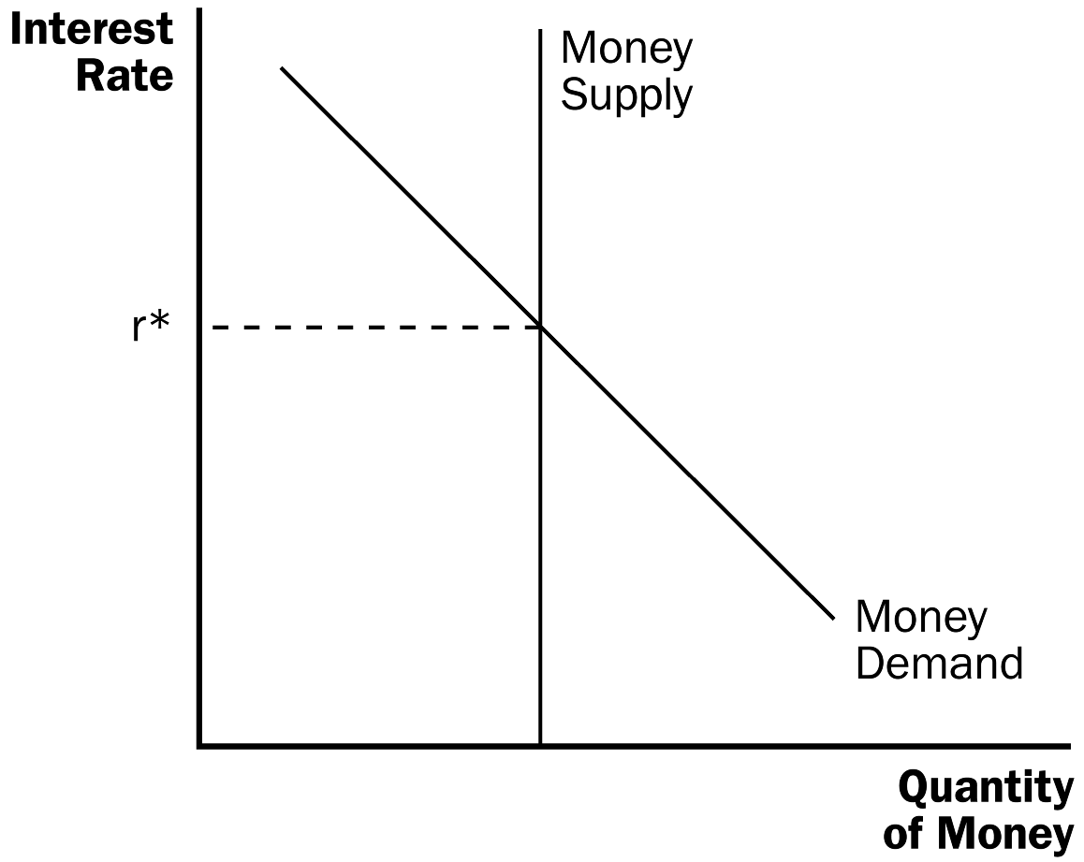

c. If the interest rate is lower than the equilibrium interest rate, the quantity of money that people want to hold is greater than the quantity that the Fed has supplied. Thus, people will try to sell bonds or withdraw funds from an interest-bearing account. This decreases the funds available for lending, pulling interest rates up.

E. FYI: Interest Rates in the Long Run and the Short Run

1. In an earlier chapter, we said that the interest rate adjusts to balance the supply and demand for loanable funds.

2. In this chapter, we proposed that the interest rate adjusts to balance the supply and demand for money.

3. To understand how these two statements can both be true, we must discuss the difference between the short run and the long run.

4. In the long run, the economy’s level of output, the interest rate, and the price level are determined by the following manner:

a. Output is determined by the levels of resources and technology available.

b. For any given level of output, the interest rate adjusts to balance the supply and demand for loanable funds.

c. Given output and the interest rate, the price level adjusts to balance the supply and demand for money. Changes in the supply of money lead to proportionate changes in the price level.

5. In the short run, the economy’s level of output, the interest rate, and the price level are determined by the following manner:

a. The price level is stuck at some level (based on previously formed expectations) and is unresponsive to changes in economic conditions.

b. For any given price level, the interest rate adjusts to balance the supply and demand for money.

c. The interest rate that balances the money market influences the quantity of goods and services demanded and thus the level of output.

F. The Downward Slope of the Aggregate-Demand Curve

Figure 2

1. When the price level increases, the quantity of money that people need to hold becomes larger. Thus, an increase in the price level leads to an increase in the demand for money, shifting the money demand curve to the right.

2. For a fixed money supply, the interest rate must rise to balance the supply and demand for money.

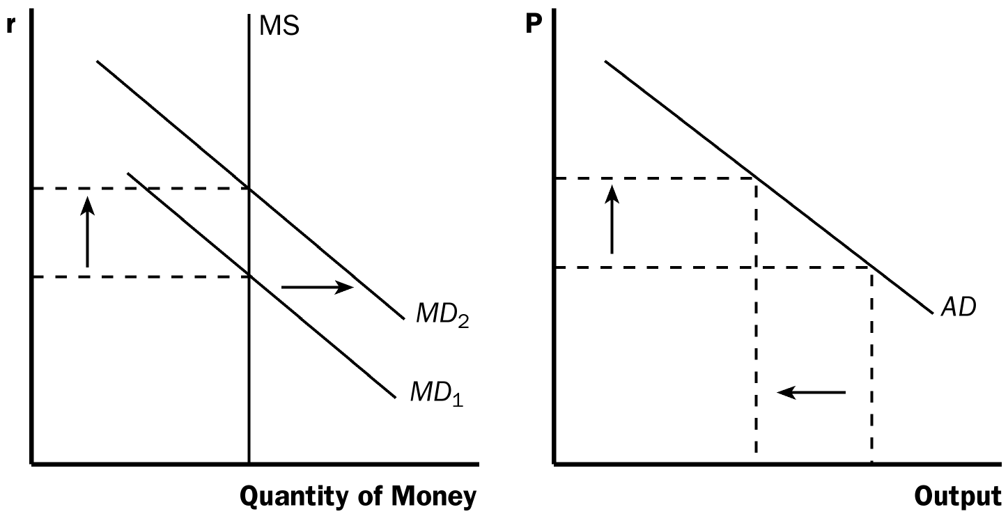

3. At a higher interest rate, the cost of borrowing and the return on saving both increase. Thus, consumers will choose to spend less and will be less likely to invest in new housing. Firms will be less likely to borrow funds for new equipment or structures. In short, the quantity of goods and services purchased in the economy will fall.

4. This implies that as the price level increases, the quantity of goods and services demanded falls. This is Keynes’s interest-rate effect.

Go through the example above in reverse as well. Make sure that students understand that a decline in the price level will lead to a drop in money demand and the interest rate and that this will cause a rise in aggregate quantity demanded.

G. Changes in the Money Supply

Figure 3

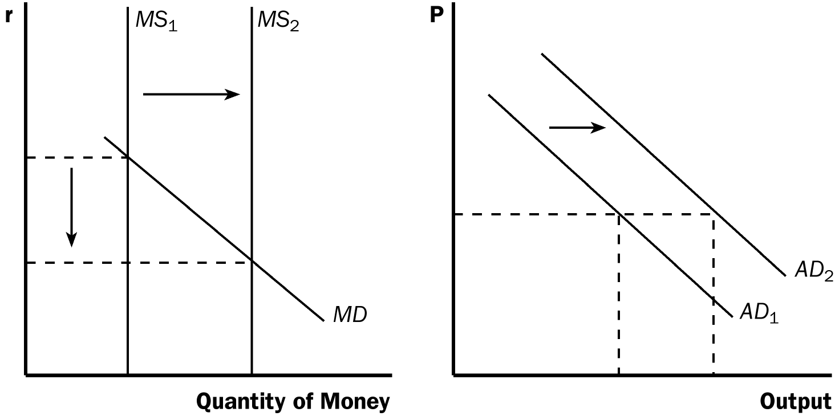

1. Example: The Fed buys government bonds in open-market operations.

ALTERNATIVE CLASSROOM EXAMPLE:
Suppose the Fed sells government bonds in the open market. The following would occur:

1. The supply of money will decrease, shifting the money supply curve to the left.
2. The equilibrium interest rate will rise, raising the cost of borrowing and the return on saving.
3. Households will lower consumption and firms will lower investment.
4. The quantity of goods and services demanded will fall at every price level, shifting the aggregate-demand curve to the left.

2. This will increase the supply of money, shifting the money supply curve to the right. The equilibrium interest rate will fall.

3. The lower interest rate reduces the cost of borrowing and the return to saving. This encourages households to increase their consumption and desire to invest in new housing. Firms will also increase investment, building new factories and purchasing new equipment.

4. The quantity of goods and services demanded will rise at every price level, shifting the aggregate-demand curve to the right.

5. Thus, a monetary injection by the Fed increases the money supply, leading to a lower interest rate, and a larger quantity of goods and services demanded.
Point out the circumstances under which the Fed is likely to increase the money supply. Then, discuss the circumstances under which the Fed is likely to decrease the money supply. Discuss the short- and long-run effects of each.
H. The Role of Interest-Rate Targets in Fed Policy
Show students that the Fed can target either the money supply or the interest rate, but not both.

1. In recent years, the Fed has conducted policy by setting a target for the federal funds rate (the interest rate that banks charge one another for short-term loans).

a. The target is reevaluated every six weeks when the Federal Open Market Committee meets.

b. The Fed has chosen to use this interest rate as a target in part because the money supply is difficult to measure with sufficient precision.

2. Because changes in the money supply lead to changes in interest rates, monetary policy can be described either in terms of the money supply or in terms of the interest rate.

Make sure that you point out to students that, while the media describes the actions of the Federal Reserve as “changing interest rates,” they instead could be described as “changing the money supply.”
I. FYI: The Zero Lower Bound

1. What if the Fed’s target interest rate is already close to zero?

2. Some economists describe this situation as a liquidity trap.

a. Nominal interest rates cannot fall below zero.

b. Expansionary monetary policy cannot work.

3. Other economists are less concerned with this situation.

a. The central bank could alter inflationary expectations.

b. The Fed could also use other financial instruments in open market operations.

J. Case Study: Why the Fed Watches the Stock Market (and Vice Versa)

1. A booming stock market expands the aggregate demand for goods and services.

a. When the stock market booms, households become wealthier, and this increased wealth stimulates consumer spending.

b. Increases in stock prices make it attractive for firms to issue new shares of stock and this increases investment spending.

2. Because one of the Fed’s goals is to stabilize aggregate demand, the Fed may respond to a booming stock market by keeping the supply of money lower and raising interest rates. The opposite would hold true if the stock market would fall.

3. Stock market participants also keep an eye on the Fed’s policy plans. When the Fed lowers the money supply, it makes stocks less attractive because alternative assets (such as bonds) pay higher interest rates. Also, higher interest rates may lower the expected profitability of firms.

II. How Fiscal Policy Influences Aggregate Demand

A. Definition of fiscal policy: the setting of the level of government spending and taxation by government policymakers.

B. Changes in Government Purchases

1. When the government changes the level of its purchases, it influences aggregate demand directly. An increase in government purchases shifts the aggregate-demand curve to the right, while a decrease in government purchases shifts the aggregate-demand curve to the left.

2. There are two macroeconomic effects that cause the size of the shift in the aggregate-demand curve to be different from the change in the level of government purchases. They are called the multiplier effect and the crowding-out effect.

C. The Multiplier Effect

Figure 4

1. Suppose that the government buys a product from a company.

a. The immediate impact of the purchase is to raise profits and employment at that firm.

b. As a result, owners and workers at this firm will see an increase in income, and will therefore likely increase their own consumption.

c. Thus, total spending rises by more than the increase in government purchases.

Pay It Forward, Chapter 10. This movie suggests that if each person could help three others do something they were not able to do alone, the world would be a much greater place. This scene provides a nice parallel to the multiplier in the economy as the benefits of each step are magnified as these good deeds are paid forward.
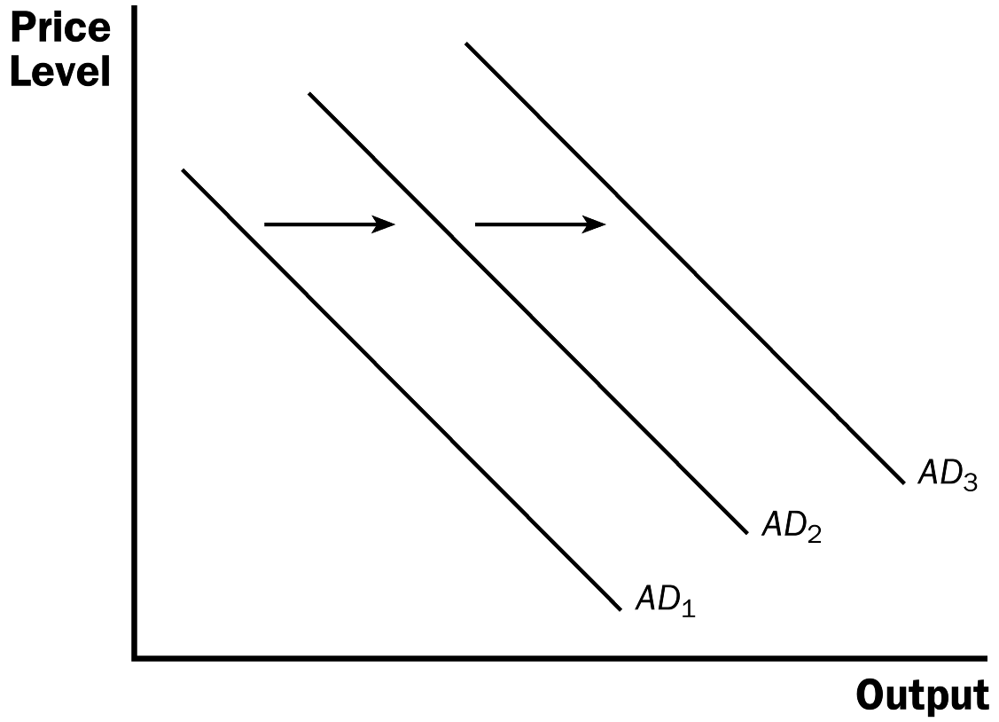

2. Definition of multiplier effect: the additional shifts in aggregate demand that result when expansionary fiscal policy increases income and thereby increases consumer spending.

3. The multiplier effect continues even after the first round.

a. When consumers spend part of their additional income, it provides additional income for other consumers.

b. These consumers then spend some of this additional income, raising the incomes of yet another group of consumers.

4. A Formula for the Spending Multiplier

a. The marginal propensity to consume (MPC ) is the fraction of extra income that a household consumes rather than saves.

b. Example: The government spends $20 billion on new planes. Assume that MPC = 3/4.

c. Incomes will increase by $20 billion, so consumption will rise by MPC × $20 billion. The second increase in consumption will be equal to MPC × (MPC × $20 billion) or MPC ² × $20 billion.

d. To find the total impact on the demand for goods and services, we add up all of these effects:
Change in government purchases = $20 billion
First change in consumption = MPC × $20 billion
Second change in consumption = MPC² × $20 billion
Third change in consumption = MPC³ × $20 billion
· ·
· ·
· ·

Total Change = (1 + MPC + MPC ² + MPC ³ + . . .) × $20 billion

e. This means that the multiplier can be written as:

Multiplier = (1 + MPC + MPC ² + MPC ³ + . . .).

f. Because this expression is an infinite geometric series, it also can be written as:
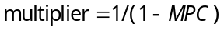

g. Note that the size of the multiplier depends on the size of the marginal propensity to consume.

5. Other Applications of the Multiplier Effect

a. The multiplier effect applies to any event that alters spending on any component of GDP (consumption, investment, government purchases, or net exports).

b. Examples include a reduction in net exports due to a recession in another country or a stock market boom that raises consumption.

D. The Crowding-Out Effect

Figure 5

1. The crowding-out effect works in the opposite direction.

2. Definition of crowding-out effect: the offset in aggregate demand that results when expansionary fiscal policy raises the interest rate and thereby reduces investment spending.

3. As we discussed earlier, when the government buys a product from a company, the immediate impact of the purchase is to raise profits and employment at that firm. As a result, owners and workers at this firm will see an increase in income, and will therefore likely increase their own consumption.

4. If consumers want to purchase more goods and services, they will need to increase their holdings of money. This shifts the demand for money to the right, pushing up the interest rate.

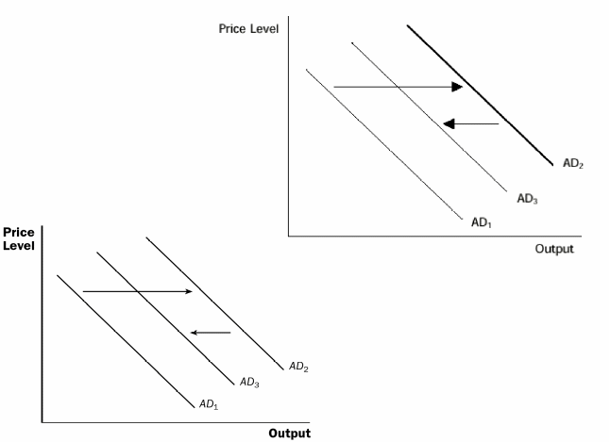

5. The higher interest rate raises the cost of borrowing and the return to saving. This discourages households from spending their incomes for new consumption or investing in new housing. Firms will also decrease investment, choosing not to build new factories or purchase new equipment.

6. Thus, even though the increase in government purchases shifts the aggregate-demand curve to the right, this fall in consumption and investment will pull aggregate demand back toward the left. Thus, aggregate demand increases by less than the increase in government purchases.

7. Therefore, when the government increases its purchases by $X, the aggregate demand for goods and services could rise by more or less than $X, depending on whether the multiplier effect or the crowding-out effect is larger.

a. If the multiplier effect is greater than the crowding-out effect, aggregate demand will rise by more than $X.

b. If the multiplier effect is less than the crowding-out effect, aggregate demand will rise by less than $X.

E. Changes in Taxes

1. Changes in taxes affect a household’s take-home pay.

a. If the government reduces taxes, households will likely spend some of this extra income, shifting the aggregate-demand curve to the right.

b. If the government raises taxes, household spending will fall, shifting the aggregate-demand curve to the left.

2. The size of the shift in the aggregate-demand curve will also depend on the sizes of the multiplier and crowding-out effects.

a. When the government lowers taxes and consumption increases, earnings and profits rise, which further stimulate consumer spending. This is the multiplier effect.

b. Higher incomes lead to greater spending, which means a higher demand for money. Interest rates rise and investment spending falls. This is the crowding-out effect.

3. Another important determinant of the size of the shift in aggregate demand due to a change in taxes is whether people believe that the tax change is permanent or temporary. A permanent tax change will have a larger effect on aggregate demand than a temporary one.

F. FYI: How Fiscal Policy Might Affect Aggregate Supply

1. Because people respond to incentives, a decrease in tax rates may cause individuals to work more, because they get to keep more of what they earn. If this occurs, the aggregate-supply curve would increase (shift to the right).

2. Changes in government purchases may also affect supply. If the government increases spending on capital projects or education, the productive ability of the economy is enhanced, shifting aggregate supply to the right.

III. Using Policy to Stabilize the Economy

If you would like, now would be a good time to cover the debate in Chapter 23 concerning whether or not policymakers should actively attempt to stabilize the economy.

A. The Case for Active Stabilization Policy

1. Example: The government reduces its spending to cut the budget deficit, lowering aggregate demand (shifting the curve to the left).

a. The Fed can offset this government action by increasing the money supply.

b. This would lower interest rates and boost spending, shifting the aggregate-demand curve back to the right.

2. Policy instruments are often used in this manner to stabilize demand. Economic stabilization has been an explicit goal of U.S. policy since the Employment Act of 1946.

a. One implication of the Employment Act is that the government should avoid being the cause of economic fluctuations.

b. The second implication of the Employment Act is that the government should respond to changes in the private economy in order to stabilize aggregate demand.

3. The Employment Act occurred in response to a book by John Maynard Keynes, an economist who emphasized the important role of aggregate demand in explaining short-run fluctuations in the economy.

4. Keynes also felt strongly that the government should stimulate aggregate demand whenever necessary to keep the economy at full employment.

a. Keynes felt that aggregate demand responds strongly to pessimism and optimism. When consumers are pessimistic, aggregate demand is low, output is low, and unemployment is increased. When consumers are optimistic, aggregate demand is high, output is high, and unemployment is lowered.

b. It is possible for the government to adjust monetary and fiscal policy in response to optimistic or pessimistic views. This helps stabilize aggregate demand, keeping output stable at full employment.

5. Case Study: Keynesians in the White House

a. In 1961, President Kennedy pushed for a tax cut to stimulate aggregate demand. Several of his economic advisers were followers of Keynes.

b. In 2009, President Obama pushed for a stimulus bill that included several increases in government spending.

6. In the News: How Large is the Fiscal Policy Multiplier?

a. During the large economic recession of 2008–2009, many governments tried using expansionary fiscal policy to stimulate aggregate demand.

b. This is an article from The Economist describing the debate over the estimated effects of these policies.

B. The Case against Active Stabilization Policy

1. Some economists believe that fiscal and monetary policy tools should only be used to help the economy achieve long-run goals, such as low inflation and rapid economic growth.

2. The primary argument against active policy is that these policy tools may affect the economy with a long lag.

a. With monetary policy, the change in money supply leads to a change in interest rates. This change in interest rates affects investment spending. However, investment decisions are usually made well in advance, so the effects from changes in investment will not likely be felt in the economy very quickly.

b. The lag in fiscal policy is generally due to the political process. Changes in spending and taxes must be approved by both the House and the Senate (after going through committees in both houses).

3. By the time these policies take effect, the condition of the economy may have changed. This could lead to even larger problems.

C. Automatic Stabilizers

1. Definition of automatic stabilizers: changes in fiscal policy that stimulate aggregate demand when the economy goes into a recession without policymakers having to take any deliberate action.

2. The most important automatic stabilizer is the tax system.

a. When the economy falls into a recession, incomes and profits fall.

b. The personal income tax depends on the level of households’ incomes and the corporate income tax depends on the level of firm profits.

c. This implies that the government’s tax revenue falls during a recession. This tax cut stimulates aggregate demand and reduces the magnitude of this economic downturn.

3. Government spending is also an automatic stabilizer.

a. More individuals become eligible for transfer payments during a recession.

b. These transfer payments provide additional income to recipients, stimulating spending.

c. Thus, just like the tax system, our system of transfer payments helps to reduce the size of short-run economic fluctuations.

SOLUTIONS TO TEXT PROBLEMS:

Quick Quizzes

1. According to the theory of liquidity preference, the interest rate adjusts to balance the supply and demand for money. Therefore, a decrease in the money supply will increase the equilibrium interest rate. This decrease in the money supply reduces aggregate demand because the higher interest rate causes households to buy fewer houses, reducing the demand for residential investment, and causes firms to spend less on new factories and new equipment, reducing business investment.

2. If the government reduces spending on highway construction by $10 billion, the aggregate-demand curve shifts to the left because government purchases are lower. The shift to the left of the aggregate-demand curve could be more than $10 billion if the multiplier effect outweighs the crowding-out effect, or it could be less than $10 billion if the crowding-out effect outweighs the multiplier effect.

3. If people become pessimistic about the future, they will spend less, causing the aggregate-demand curve to shift to the left. If the Fed wants to stabilize aggregate demand, it should increase the money supply. The increase in the money supply will cause the interest rate to decline, thus stimulating residential and business investment. The Fed might choose not to do this because by the time the policy action takes effect, the long lag time might mean the economy would have recovered on its own, and the increase in the money supply will cause inflation.

Questions for Review

1. The theory of liquidity preference is Keynes's theory of how the interest rate is determined. According to the theory, the aggregate-demand curve slopes downward because: (1) a higher price level raises money demand; (2) higher money demand leads to a higher interest rate; and (3) a higher interest rate reduces the quantity of goods and services demanded. Thus, the price level has a negative relationship with the quantity of goods and services demanded.

2. A decrease in the money supply shifts the money-supply curve to the left. The equilibrium interest rate will rise. The higher interest rate reduces consumption and investment, so aggregate demand falls. Thus, the aggregate-demand curve shifts to the left.

3. If the government spends $3 billion to buy police cars, aggregate demand might increase by more than $3 billion because of the multiplier effect on aggregate demand. Aggregate demand might increase by less than $3 billion because of the crowding-out effect on aggregate demand.

4. If pessimism sweeps the country, households reduce consumption spending and firms reduce investment, so aggregate demand falls. If the Fed wants to stabilize aggregate demand, it must increase the money supply, reducing the interest rate, which will induce households to save less and spend more and will encourage firms to invest more, both of which will increase aggregate demand. If the Fed does not increase the money supply, Congress could increase government purchases or reduce taxes to increase aggregate demand.

5. Government policies that act as automatic stabilizers include the tax system and government spending through the unemployment-benefit system. The tax system acts as an automatic stabilizer because when incomes are high, people pay more in taxes, so they cannot spend as much. When incomes are low, so are taxes; thus, people can spend more. The result is that spending is partly stabilized. Government spending through the unemployment-benefit system acts as an automatic stabilizer because in recessions the government transfers money to the unemployed so their incomes do not fall as much and thus their spending will not fall as much.

Problems and Applications

1. a. When the Fed’s bond traders buy bonds in open-market operations, the money-supply curve shifts to the right from MS ₁ to MS ₂, as shown in Figure 1. The result is a decline in the interest rate.

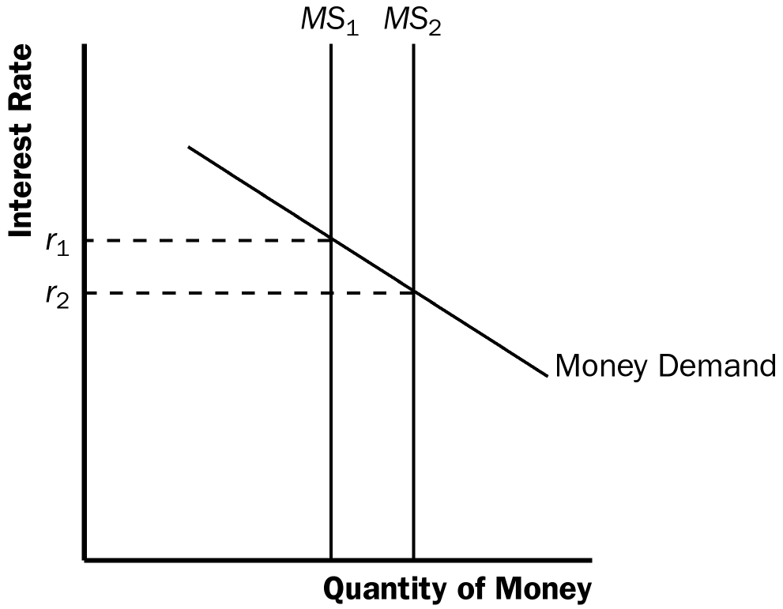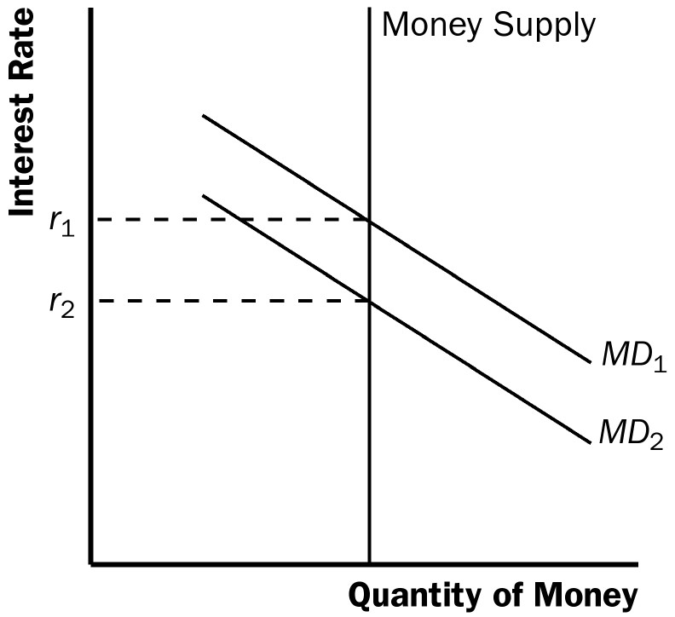

Figure 1 Figure 2

b. When an increase in credit card availability reduces the cash people hold, the money-demand curve shifts to the left from MD ₁ to MD ₂, as shown in Figure 2. The result is a decline in the interest rate.

c. When the Federal Reserve reduces reserve requirements, the money supply increases, so the money-supply curve shifts to the right from MS ₁ to MS ₂, as shown in Figure 1. The result is a decline in the interest rate.

d. When households decide to hold more money to use for holiday shopping, the money-demand curve shifts to the right from MD ₁ to MD ₂, as shown in Figure 3. The result is a rise in the interest rate.

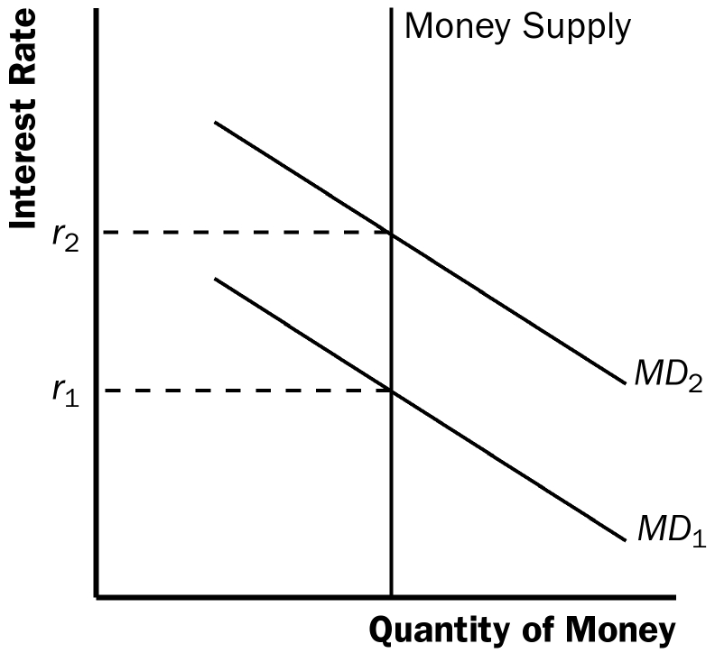

Figure 3

e. When a wave of optimism boosts business investment and expands aggregate demand, money demand increases from MD ₁ to MD ₂ in Figure 3. The increase in money demand increases the interest rate.

Figure 4

2. a. The increase in the money supply will cause the equilibrium interest rate to decline, as shown in Figure 4. Households will increase spending and will invest in more new housing. Firms too will increase investment spending. This will cause the aggregate demand curve to shift to the right as shown in Figure 5.

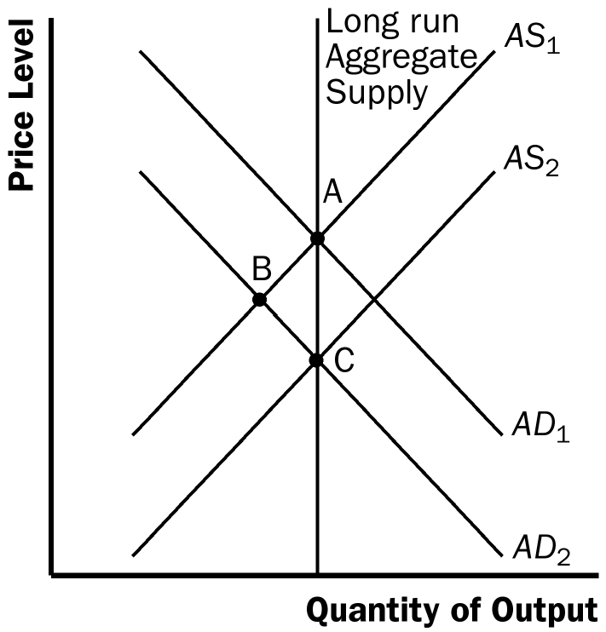
Figure 5

b. As shown in Figure 5, the increase in aggregate demand will cause an increase in both output and the price level in the short run (point B).

c. When the economy makes the transition from its short-run equilibrium to its long-run equilibrium, short-run aggregate supply will decline, causing the price level to rise even further (point C).

d. The increase in the price level will cause an increase in the demand for money, raising the equilibrium interest rate.

e. Yes. While output initially rises because of the increase in aggregate demand, it will fall once short-run aggregate supply declines. Thus, there is no long-run effect of the increase in the money supply on real output.

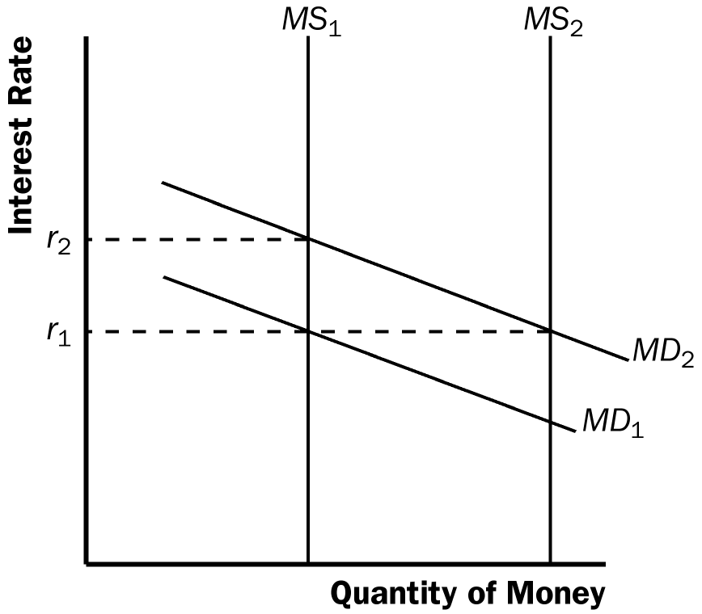

Figure 6

3. a. When fewer ATMs are available, money demand is increased and the money-demand curve shifts to the right from MD ₁ to MD ₂, as shown in Figure 6. If the Fed does not change the money supply, which is at MS₁, the interest rate will rise from r₁ to r₂. The increase in the interest rate shifts the aggregate-demand curve to the left, as consumption and investment fall.

b. If the Fed wants to stabilize aggregate demand, it should increase the money supply to MS ₂, so the interest rate will remain at r₁ and aggregate demand will not change.

c. To increase the money supply using open market operations, the Fed should buy government bonds.

4. A tax cut that is permanent will have a bigger impact on consumer spending and aggregate demand. If the tax cut is permanent, consumers will view it as adding substantially to their financial resources, and they will increase their spending substantially. If the tax cut is temporary, consumers will view it as adding just a little to their financial resources, so they will not increase spending as much.

5. a. The current situation is shown in Figure 7.

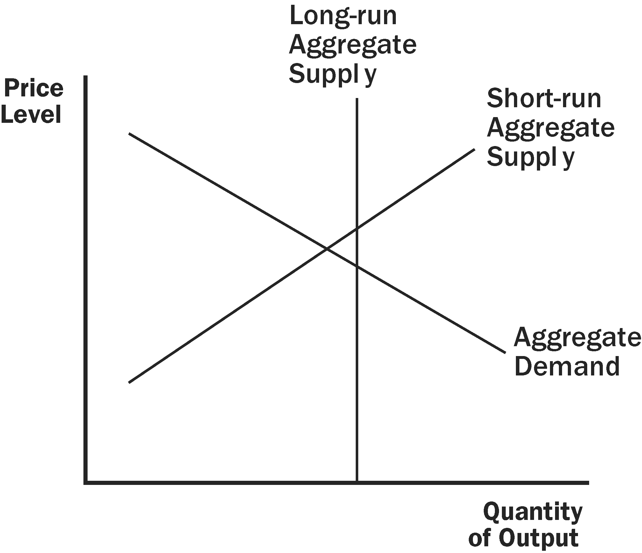

Figure 7

b. The Fed will want to stimulate aggregate demand. Thus, it will need to lower the interest rate by increasing the money supply. This could be achieved if the Fed purchases government bonds from the public.

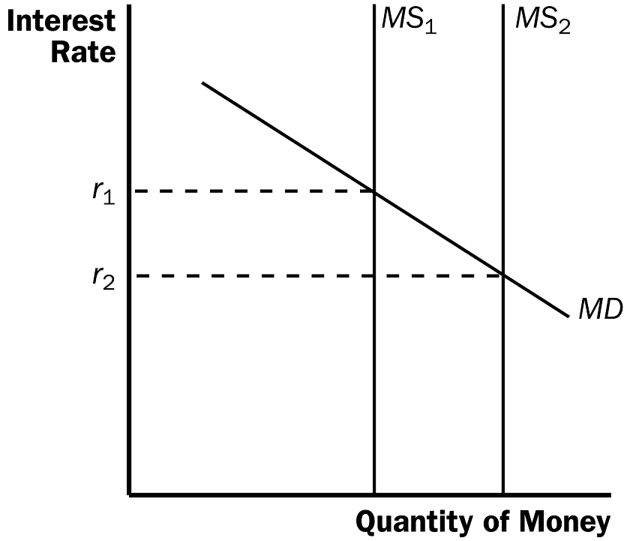

Figure 8

c. As shown in Figure 8, the Fed's purchase of government bonds shifts the supply of money to the right, lowering the interest rate.

d. The Fed's purchase of government bonds will increase aggregate demand as consumers and firms respond to lower interest rates. Output and the price level will rise as shown in Figure 9.

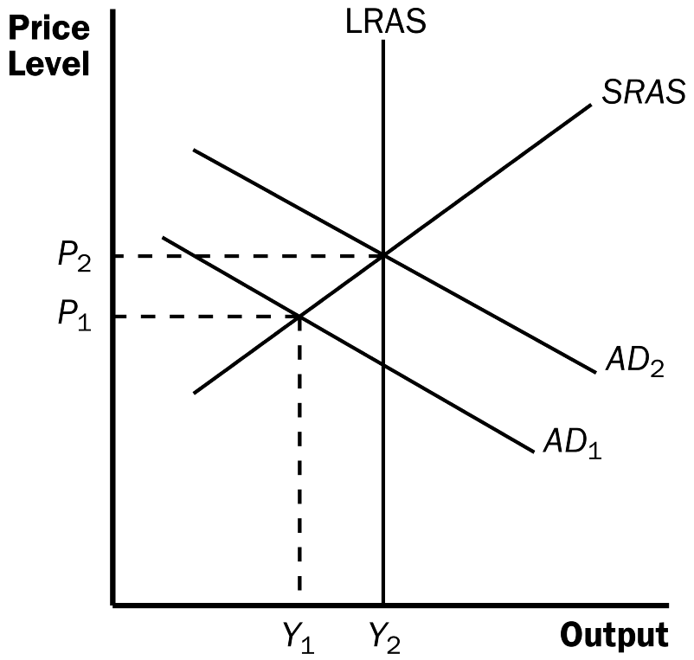

Figure 9

6. a. Legislation allowing banks to pay interest on checking deposits increases the return to money relative to other financial assets, thus increasing money demand.

b. If the money supply remained constant (at MS₁), the increase in the demand for money would have raised the interest rate, as shown in Figure 10. The rise in the interest rate would have reduced consumption and investment, thus reducing aggregate demand and output.

c. To maintain a constant interest rate, the Fed would need to increase the money supply from MS ₁ to MS ₂. Then aggregate demand and output would be unaffected.

Figure 10

7. a. If there is no crowding out, then the multiplier equals 1/(1 – MPC ). Because the multiplier is 3, then MPC = 2/3.

b. If there is crowding out, then the MPC would be larger than 2/3. An MPC that is larger than 2/3 would lead to a larger multiplier than 3, which is then reduced down to 3 by the crowding-out effect.

8. a. The initial effect of the tax reduction of $20 billion is to increase aggregate demand by $20 billion × 3/4 (the MPC ) = $15 billion.

b. Additional effects follow this initial effect as the added incomes are spent. The second round leads to increased consumption spending of $15 billion × 3/4 = $11.25 billion. The third round gives an increase in consumption of $11.25 billion × 3/4 = $8.44 billion. The effects continue indefinitely. Adding them all up gives a total effect that depends on the multiplier. With an MPC of 3/4, the multiplier is 1/(1 – 3/4) = 4. So the total effect is $15 billion × 4 = $60 billion.

c. Government purchases have an initial effect of the full $20 billion, because they increase aggregate demand directly by that amount. The total effect of an increase in government purchases is thus $20 billion × 4 = $80 billion. So government purchases lead to a bigger effect on output than a tax cut does. The difference arises because government purchases affect aggregate demand by the full amount, but a tax cut is partly saved by consumers, and therefore does not lead to as much of an increase in aggregate demand.

d. The government could increase taxes by the same amount it increases its purchases.

9. If the marginal propensity to consume is 0.8, the spending multiplier will be 1/(1 – 0.8) = 5. Therefore, the government would have to increase spending by $400/5 = $80 billion to close the recessionary gap.
10. If government spending increases, aggregate demand rises, so money demand rises. The increase in money demand leads to a rise in the interest rate and thus a decline in aggregate demand if the Fed keeps the money supply constant. But if the Fed maintains a fixed interest rate, it will increase money supply, so aggregate demand will not decline. Thus, the effect on aggregate demand from an increase in government spending will be larger if the Fed maintains a fixed interest rate.

11. a. Expansionary fiscal policy is more likely to lead to a short-run increase in investment if the investment accelerator is large. A large investment accelerator means that the increase in output caused by expansionary fiscal policy will induce a large increase in investment. Without a large accelerator, investment might decline because the increase in aggregate demand will raise the interest rate.

b. Expansionary fiscal policy is more likely to lead to a short-run increase in investment if the interest sensitivity of investment is small. Because fiscal policy increases aggregate demand, thus increasing money demand and the interest rate, the greater the sensitivity of investment to the interest rate the greater the decline in investment will be, which will offset the positive accelerator effect.

12. a. Tax revenue declines when the economy goes into a recession because taxes are closely related to economic activity. In a recession, people's incomes and wages fall, as do firms' profits, so taxes on these things decline.

b. Government spending rises when the economy goes into a recession because more people get unemployment-insurance benefits, welfare benefits, and other forms of income support.

c. If the government were to operate under a strict balanced-budget rule, it would have to raise tax rates or cut government spending in a recession. Both would reduce aggregate demand, making the recession more severe.

13. a. If there were a contraction in aggregate demand, the Fed would need to increase the money supply to increase aggregate demand and stabilize the price level, as shown in Figure 11. By increasing the money supply, the Fed is able to shift the aggregate-demand curve back to AD ₁ from AD ₂. This policy stabilizes output and the price level.

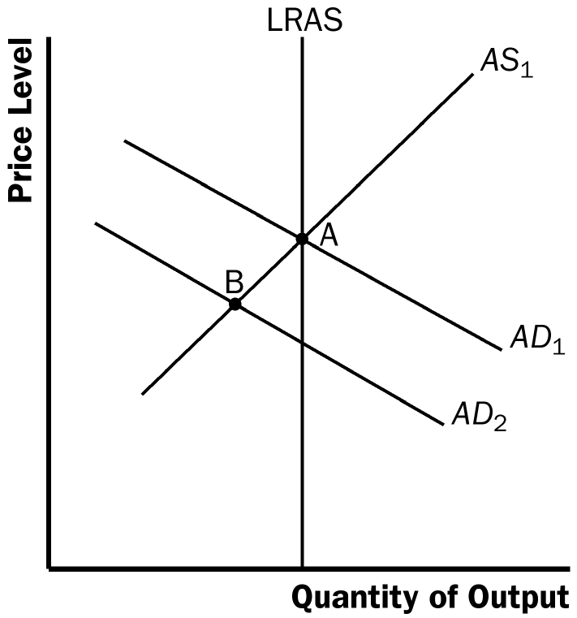

Figure 11

b. If there were an adverse shift in short-run aggregate supply, the Fed would need to decrease the money supply to stabilize the price level, shifting the aggregate-demand curve to the left from AD ₁ to AD ₂, as shown in Figure 12. This worsens the recession caused by the shift in aggregate supply. To stabilize output, the Fed would need to increase the money supply, shifting the aggregate-demand curve from AD ₁ to AD ₃. However, this action would raise the price level.

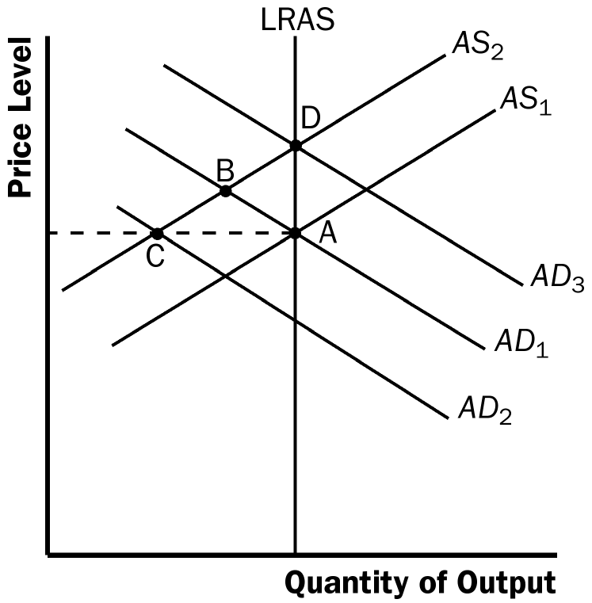

Figure 12

