16
stic Competition

MONOPOLISTIC COMPETITION

WHAT’S NEW IN THE SIXTH EDITION:

There are no major changes to this chapter.

LEARNING OBJECTIVES:

By the end of this chapter, students should understand:

➢ what market structures lie between monopoly and competition.

➢ competition among firms that sell differentiated products.

➢ how the outcomes under monopolistic competition and under perfect competition compare.

➢ the desirability of outcomes in monopolistically competitive markets.

➢ the debate over the effects of advertising.

➢ the debate over the role of brand names.

CONTEXT AND PURPOSE:

Chapter 16 is the fourth chapter in a five-chapter sequence dealing with firm behavior and the organization of industry. The previous two chapters developed the two extreme forms of market structure—competition and monopoly. The market structure that lies between competition and monopoly is known as imperfect competition. There are two types of imperfect competition—monopolistic competition and oligopoly. This chapter addresses monopolistic competition while the final chapter in the sequence addresses oligopoly. The analysis in this chapter is again based on the cost curves developed in Chapter 13.
The purpose of Chapter 16 is to address monopolistic competition—a market structure in which many firms sell products that are similar but not identical. Monopolistic competition differs from perfect competition because each of the many sellers offers a somewhat different product. As a result, monopolistically competitive firms face a downward-sloping demand curve while competitive firms face a horizontal demand curve at the market price. Monopolistic competition is extremely common.

KEY POINTS:

• A monopolistically competitive market is characterized by three attributes: many firms, differentiated products, and free entry.

• The equilibrium in a monopolistically competitive market differs from that in a perfectly competitive market in two related ways. First, each firm has excess capacity. That is, it operates on the downward-sloping portion of the average-total-cost curve. Second, each firm charges a price above marginal cost.

• Monopolistic competition does not have all of the desirable properties of perfect competition. There is the standard deadweight loss of monopoly caused by the markup of price over marginal cost. In addition, the number of firms (and thus the variety of products) can be too large or too small. In practice, the ability of policymakers to correct these inefficiencies is limited.

• The product differentiation inherent in monopolistic competition leads to the use of advertising and brand names. Critics of advertising and brand names argue that firms use them to manipulate consumers’ tastes and to reduce competition. Defenders of advertising and brand names argue that firms use them to inform consumers and to compete more vigorously on price and product quality.

CHAPTER OUTLINE:

I. Between Monopoly and Perfect Competition
Figure 1

A. The typical firm has some market power, but its market power is not as great as that described by monopoly.

B. Firms in imperfect competition lie somewhere between the competitive model and the monopoly model.

C. Definition of oligopoly: a market structure in which only a few sellers offer similar or identical products.

1. Economists measure a market’s domination by a small number of firms with a statistic called a concentration ratio.

2. The concentration ratio is the percentage of total output in the market supplied by the four largest firms.

3. In the U.S. economy, most industries have a four-firm concentration ratio under 50%.

D. Definition of monopolistic competition: a market structure in which many firms sell products that are similar but not identical.

1. Characteristics of Monopolistic Competition

a. Many Sellers

b. Product Differentiation

Seinfeld, “The Café.” (Season 3, 11:37-12:46; 19:06-20:01; 21:00-21:35.) Jerry convinces Babu to serve Pakistani food—he'll be the only Pakistani restaurant in the neighborhood. Babu tells Jerry that the restaurant is failing and that Jerry is a very bad man. Babu's restaurant then closes. Jerry blames it on a bad location. This is a good clip to introduce the concept of product differentiation including product characteristics and location.



c. Free Entry

E. Figure 1 summarizes the four types of market structure. Note that it is the number of firms and the type of product sold that distinguishes one market structure from another.

Draw a table with the four types of markets across the top. Create rows for various market characteristics such as type of product sold, number of firms, control over price, freedom of entry and exit, and ability to earn profit in the long run. Students will then be able to see how these characteristics relate to one another.

Activity 1—Think of a Firm

Type: In-class assignment
Topics: Market structure
Materials needed: None
Time: 15 minutes
Class limitations: Works in any size class

Purpose
This assignment helps students relate the concept of market structure to the real world.

Instructions
Ask the class to answer the following questions. After they have answered all of them, ask the students to share their answers with a neighbor. Ask the neighboring student to evaluate the answer to the last question. List the four market structures on the board and ask for examples that fit each category
1. Write the name of a specific firm. It should be a real company, not hypothetical.
2. What products or services does this firm sell? If the firm sells a wide variety of goods, choose a single item to answer the following questions.
3. What other firms compete with this company? Are there many competitors, only a few, or none?
4. Do the competing firms sell exactly the same product or does each company produce goods with special characteristics?
5. Categorize the industry as one of the following market structures:
a. Perfect competition
— many firms
— identical products
b. Monopoly
— one firm
— unique product

c. Oligopoly
— a few firms
— standard or differentiated product
d. Monopolistic competition
— many firms
— differentiated products

Common Answers and Points for Discussion
Many students will choose companies that produce consumer goods, where product differentiation is the most important characteristic. Most of these industries are either oligopolies or monopolistically competitive. A few students may have examples of monopoly, particularly utilities or patented medicines. Almost no one will give an example of perfect competition.

Perfect competition, while an economic ideal, does not accurately describe all sectors of the economy. Explaining that perfect competition is a special case (and adding some examples of competitive industries) will help students understand why competitive firms face a horizontal demand curve and have no control over the prices of their products.

Some students may have questions about the differences between oligopoly and monopolistic competition. Differentiating between a “few” and “many” is not always easy. Measures of market concentration can be used to explain the difference between these two imperfectly competitive market structures.

II. Competition with Differentiated Products

A. The Monopolistically Competitive Firm in the Short Run
Figure 2

1. Each firm in monopolistic competition faces a downward-sloping demand curve because its product is different from those offered by other firms.

2. The monopolistically competitive firm follows a monopolist's rule for maximizing profit.

Explain to students that product differentiation gives the seller in a monopolistically competitive market some ability to control the price of its product. In a sense, each firm is a monopoly in the production of its particular version of the product. This is reflected by the fact that these firms face a downward-sloping demand curve. Point out that the graph looks something like a monopoly, but that the demand the firm faces will likely be much flatter (because it will be more elastic).

a. It chooses the output level where marginal revenue is equal to marginal cost.

b. It sets the price using the demand curve to ensure that consumers will demand exactly the amount produced.

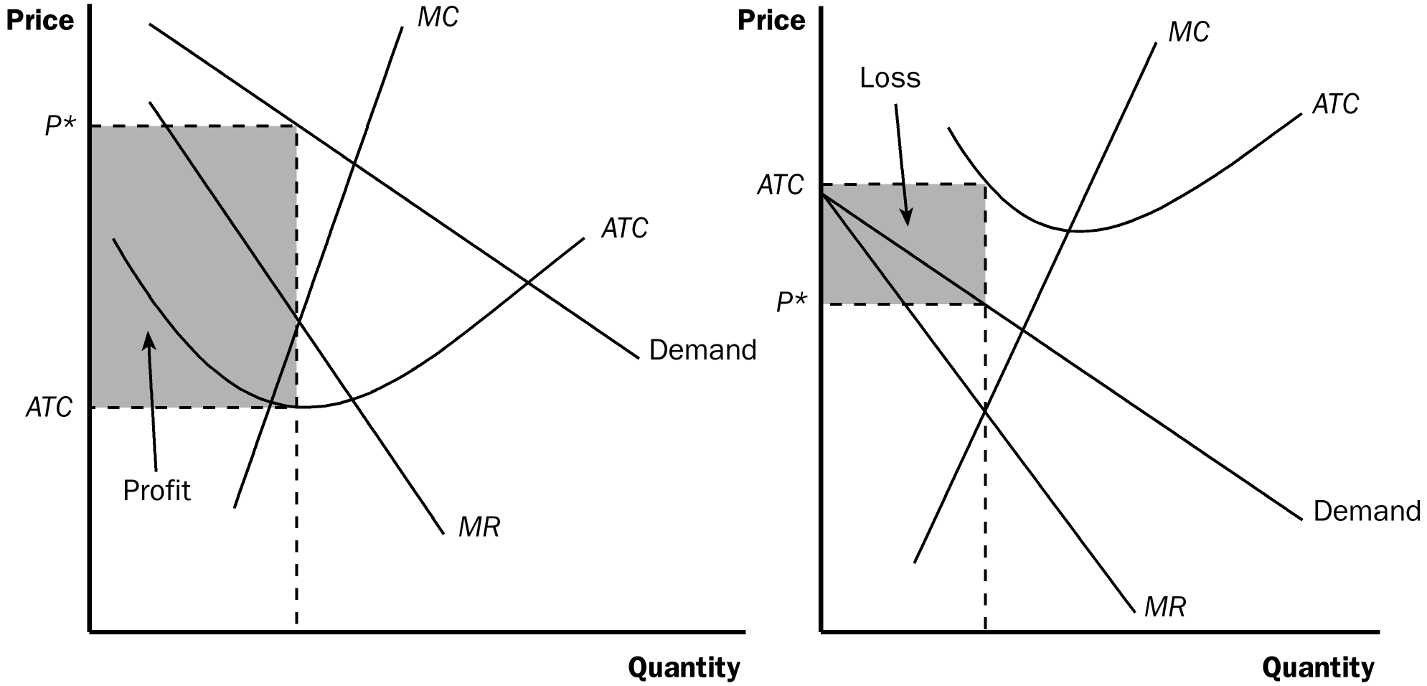

3. We can determine whether or not the monopolistically competitive firm is earning a profit or loss by comparing price and average total cost.

a. If P > ATC, the firm is earning a profit.

b. If P < ATC, the firm is earning a loss.

c. If P = ATC, the firm is earning zero economic profit.

B. The Long-Run Equilibrium
Figure 3

1. When firms in monopolistic competition are making profit, new firms have an incentive to enter the market.

a. This increases the number of products from which consumers can choose.

b. Thus, the demand curve faced by each firm shifts to the left.

c. As the demand falls, these firms experience declining profit.

2. When firms in monopolistic competition are incurring losses, firms in the market will have an incentive to exit.

a. Consumers will have fewer products from which to choose.

b. Thus, the demand curve for each firm shifts to the right.

c. The losses of the remaining firms will fall.

3. The process of exit and entry continues until the firms in the market are earning zero profit.

a. This means that the demand curve and the average-total-cost curve are tangent to each other.

b. At this point, price is equal to average total cost and the firm is earning zero economic profit.

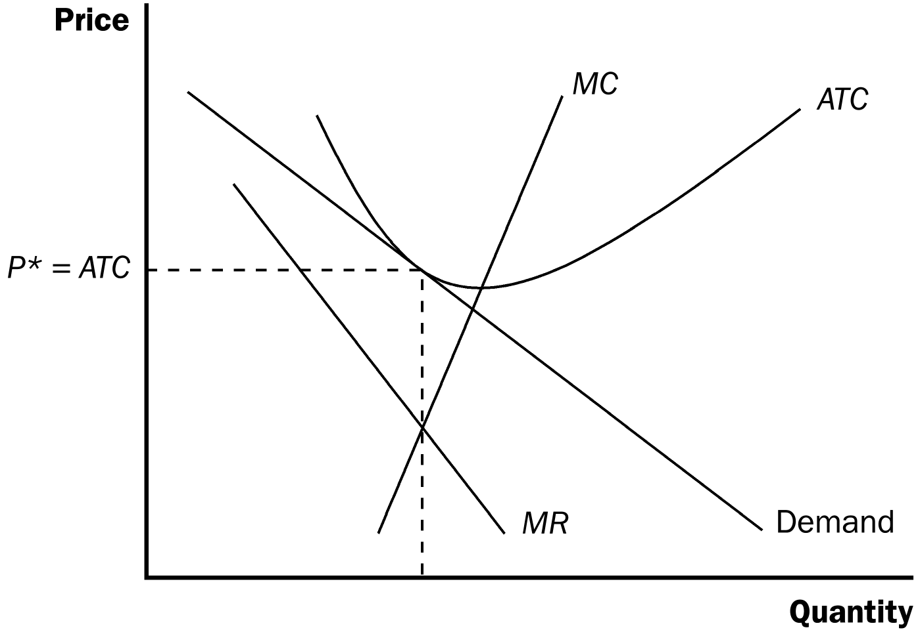

Remember that students have a hard time understanding why a firm will continue to operate if it is earning “only” zero economic profit. Remind them that zero economic profit means that firms are earning an accounting profit equal to their implicit costs.

Point out to students that, just like firms in perfect competition, firms in monopolistic competition also earn zero economic profit in the long run. Show them that this result occurs because firms can freely enter the market when profits occur, driving the level of profits to zero. Any market with no barriers to entry will see zero economic profit in the long run.
4. There are two characteristics that describe the long-run equilibrium in a monopolistically competitive market.

a. Price exceeds marginal cost (due to the fact that each firm faces a downward-sloping demand curve).

b. Price equals average total cost (due to the freedom of entry and exit).

C. Monopolistic versus Perfect Competition
Figure 4

1. Excess Capacity

a. The quantity of output produced by a monopolistically competitive firm is smaller than the quantity that minimizes average total cost (the efficient scale).

b. This implies that firms in monopolistic competition have excess capacity, because the firm could increase its output and lower its average total cost of production.

c. Because firms in perfect competition produce where price is equal to the minimum average total cost, firms in perfect competition produce at their efficient scale.

2. Markup over Marginal Cost

a. In monopolistic competition, price is greater than marginal cost because the firm has some market power.

b. In perfect competition, price is equal to marginal cost.

D. Monopolistic Competition and the Welfare of Society

1. One source of inefficiency is the markup over marginal cost. This implies a deadweight loss (similar to that caused by monopolies).

2. Because there are so many firms in this type of market structure, regulating these firms would be difficult.

3. Also, forcing these firms to set price equal to marginal cost would force them out of business (because they are already earning zero economic profit).

4. There are also externalities associated with entry.

a. The product-variety externality occurs because as new firms enter, consumers get some consumer surplus from the introduction of a new product. Note that this is a positive externality.

b. The business-stealing externality occurs because as new firms enter, other firms lose customers and profit. Note that this is a negative externality.

c. Depending on which externality is larger, a monopolistically competitive market could have too few or too many products.

5. In the News: Insufficient Variety as a Market Failure

a. Economist Joel Waldfogel argues that firms may insufficiently service consumers with unusual preferences.

b. This is an article that describes how some consumers get left out of the market because of the high fixed costs associated with creating additional varieties of a product.

III. Advertising

A. The Debate over Advertising

1. The Critique of Advertising

a. Firms advertise to manipulate people's tastes.

b. Advertising impedes competition because it increases the perception of product differentiation and fosters brand loyalty. This means that consumers will be less concerned with price differences among similar goods.

2. The Defense of Advertising

a. Firms use advertising to provide information to consumers.

b. Advertising fosters competition because it allows consumers to be better informed about all of the firms in the market.

3. Case Study: Advertising and the Price of Eyeglasses

a. In the United States during the 1960s, states differed on whether or not they allowed advertising for optometrists.

b. In the states that prohibited advertising, the average price paid for a pair of eyeglasses in 1963 was $33; in states that allowed advertising, the average price was $26 (a difference of more than 20%).

4. FYI: Galbraith versus Hayek

a. In The Affluent Society (published in 1958), John Kenneth Galbraith argued that corporations use advertising to create demand for products that people otherwise do not want or need.

b. Friedrich Hayek wrote a well-known critique of Galbraith in 1961. He observed that advertising was merely one way in which preferences are created by the social environment.

B. Advertising as a Signal of Quality

1. The willingness of a firm to spend a large amount of money on advertising may be a signal to consumers about the quality of the product being offered.

2. Example: Kellogg and Post have each developed a new cereal that would sell for $3 per box. (Assume that the marginal cost of producing the cereal is zero.) Each company knows that if it spends $10 million on advertising, it will get one million new consumers to try the product. If consumers like the product, they will buy it again.

a. Post has discovered through market research that its new cereal is not very good. After buying it once, consumers would not likely buy it again. Thus, it will only earn $3 million in revenue, which would not be enough to pay for the advertising. Therefore, it does not advertise.

b. Kellogg knows that its cereal is great. Each person that buys it will likely buy one box per month for the next year. Therefore, its sales would be $36 million, which is more than enough to justify the advertisement.

c. By its willingness to spend money on advertising, Kellogg signals to consumers the quality of its cereal.

3. Note that the content of the advertisement is unimportant; what is important is that consumers know that the advertisements are expensive.

C. Brand Names

1. In many markets there are two types of firms; some firms sell products with widely recognized brand names while others sell generic substitutes.

2. Critics of brand names argue that they cause consumers to perceive differences that do not really exist.

3. Economists have defended brand names as a useful way to ensure that goods are of high quality.

a. Brand names provide consumers with information about quality when quality cannot be judged easily in advance of purchase.

b. Brand names give firms an incentive to maintain high quality, because firms have a financial stake in maintaining the reputation of their brand names.
Table 1

Activity 2—Equilibrium Price for Blue Jeans

Type: In-class demonstration
Topics: Product differentiation
Materials needed: None
Time: 5 minutes
Class limitations: Works in any size class

Purpose
This assignment shows that market supply and demand graphs give an oversimplified picture of price when products are diversified.

Instructions
Ask the students to draw a supply and demand graph illustrating the market for blue jeans. After they have drawn the graph, have them label the equilibrium price with a real dollar figure. This dollar amount should reflect the price of jeans as accurately as possible.

Draw a standard supply and demand graph on the board. Ask a student for the equilibrium price. Ask several more students for their prices.

Common Answers and Points for Discussion
The class will have a whole range of prices for blue jeans, reflecting the range of blue jeans in the real world. Recent prices at one shopping mall varied from $14 to more than $100 for a pair of blue jeans. The price differences reflect product differentiation. Quality, style, and reputation all affect the price of jeans. The simple supply and demand diagram can be useful for broad analysis of the market for jeans, but individual prices and quantities are determined by the demand and cost curves of the individual products.

SOLUTIONS TO TEXT PROBLEMS:

Quick Quizzes

1. Oligopoly is a market structure in which only a few sellers offer similar or identical products. Examples include the market for breakfast cereals and the world market for crude oil. Monopolistic competition is a market structure in which many firms sell products that are similar but not identical. Examples include the markets for novels, movies, restaurant meals, and computer games.

2. The three key attributes of monopolistic competition are: (1) there are many sellers; (2) each firm produces a slightly different product; and (3) firms can enter or exit the market freely.

Figure 1 shows the long-run equilibrium in a monopolistically competitive market. This equilibrium differs from that in a perfectly competitive market because price exceeds marginal cost and the firm does not produce at the minimum point of average total cost but instead produces at less than the efficient scale.

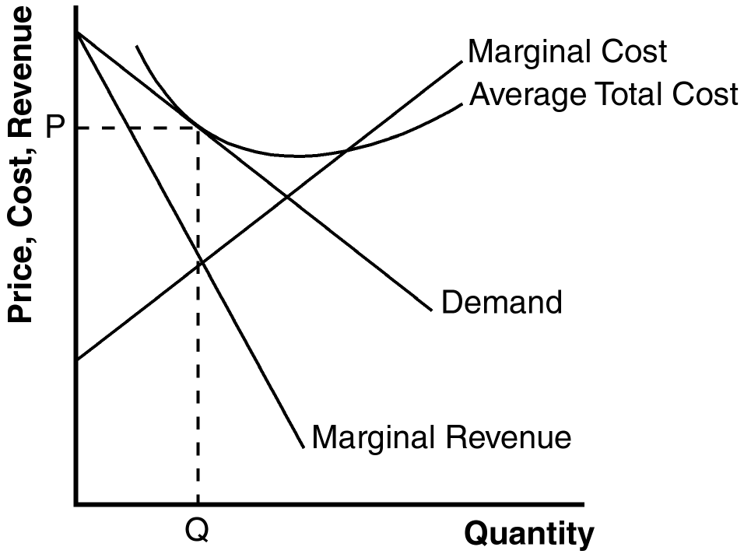

Figure 1

3. Advertising may make markets less competitive if it manipulates people’s tastes rather than being informative. Advertising may give consumers the perception that there is a greater difference between two products than really exists. That makes the demand curve for a product more inelastic, so the firms can then charge greater markups over marginal cost. However, some advertising could make markets more competitive because it sometimes provides useful information to consumers, allowing them to take advantage of price differences more easily. Advertising also facilitates entry because it can be used to inform consumers about a new product. In addition, expensive advertising can be a signal of quality.

Brand names may be beneficial because they provide information to consumers about the quality of goods. They also give firms an incentive to maintain high quality, since their reputations are important. But brand names may be criticized because they may simply differentiate products that are not really different, as in the case of drugs that are identical with the brand-name drug selling at a much higher price than the generic drug.

Questions for Review

1. The three attributes of monopolistic competition are: (1) there are many sellers; (2) each seller produces a slightly different product; and (3) firms can enter or exit the market without restriction. Monopolistic competition is like monopoly because firms face a downward-sloping demand curve, so price exceeds marginal cost. Monopolistic competition is like perfect competition because, in the long run, price equals average total cost, as free entry and exit drive economic profit to zero.

2. In Figure 2, a firm has demand curve D₁ and marginal-revenue curve MR₁. The firm is making profits because at quantity Q₁, price (P₁) is above average total cost (ATC). Those profits induce other firms to enter the industry, causing the demand curve to shift to D₂ and the marginal-revenue curve to shift to MR₂. The result is a decline in quantity to Q₂, at which point the price (P₂) equals average total cost (ATC), so profits are now zero.

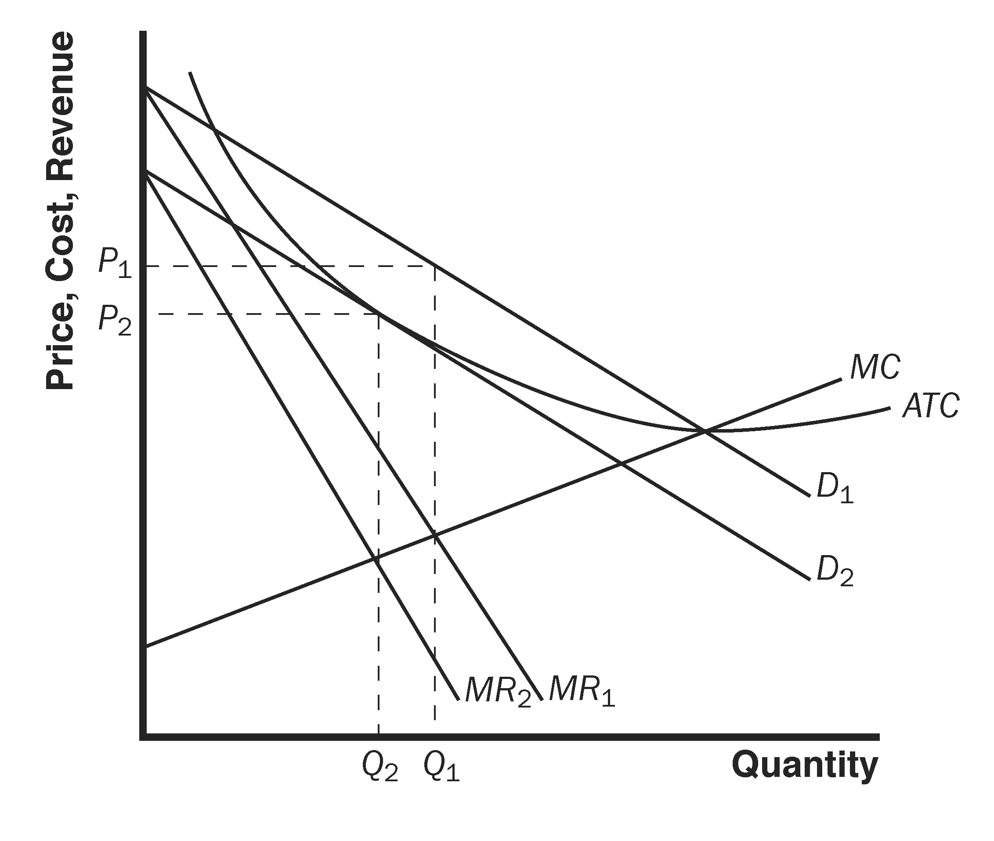

Figure 2

3. Figure 3 shows the long-run equilibrium in a monopolistically competitive market. Price equals average total cost. Price is above marginal cost.

Figure 3

4. Because, in equilibrium, price is above marginal cost, a monopolistic competitor produces too little output. But this is a hard problem to solve because: (1) the administrative burden of regulating the large number of monopolistically competitive firms would be high; and (2) the firms are earning zero economic profits, so forcing them to price at marginal cost means that firms would lose money unless the government subsidized them.

5. Advertising might reduce economic well-being because it manipulates people's tastes and impedes competition by making products appear more different than they really are. But advertising might increase economic well-being by providing useful information to consumers and fostering competition.

6. Advertising with no apparent informational content might convey information to consumers if it provides a signal of quality. A firm will not be willing to spend much money advertising a low-quality good, but may be willing to spend significantly more to advertise a high-quality good.

7. The two benefits that might arise from the existence of brand names are: (1) brand names provide consumers information about quality when quality cannot be easily judged in advance; and (2) brand names give firms an incentive to maintain high quality to maintain the reputation of their brand names.

Problems and Applications

1. a. Tap water is a perfectly competitive market because there are many taps and the product does not differ across sellers.

b. Bottled water is a monopolistically competitive market. There are many sellers of bottled water, but each firm tries to differentiate its own brand from the rest.

c. The cola market is an oligopoly. There are only a few firms that control a large portion of the market.

d. The beer market is an oligopoly. There are only a few firms that control a large portion of the market.

2. a. The market for wooden #2 pencils is perfectly competitive because pencils by any manufacturer are identical and there are a large number of manufacturers.

b. The market for copper is perfectly competitive, because all copper is identical and there are a large number of producers.

c. The market for local telephone service is monopolistic because it is a natural monopoly—it is cheaper for one firm to supply all the output.

d. The market for peanut butter is monopolistically competitive because different brand names exist with different quality characteristics.

e. The market for lipstick is monopolistically competitive because lipstick from different firms differs slightly, but there are a large number of firms that can enter or exit without restriction.

3. a. A firm in monopolistic competition sells a differentiated product from its competitors.

b. A firm in monopolistic competition has marginal revenue less than price.

c. Neither a firm in monopolistic competition nor in perfect competition earns economic profit in the long run.

d. A firm in perfect competition produces at the minimum average total cost in the long run.

e. Both a firm in monopolistic competition and a firm in perfect competition equate marginal revenue and marginal cost.

f. A firm in monopolistic competition charges a price above marginal cost.

4. a. Both a firm in monopolistic competition and a monopoly firm face a downward-sloping demand curve.

b. Both a firm in monopolistic competition and a monopoly firm have marginal revenue that is less than price.

c. A firm in monopolistic competition faces the entry of new firms selling similar products.

d. A monopoly firm earns economic profit in the long run.

e. Both a firm in monopolistic competition and a monopoly firm equate marginal revenue and marginal cost.

f. Neither a firm in monopolistic competition nor a monopoly firm produce the socially efficient quantity of output.

5. a. The firm is not maximizing profit. For a firm in monopolistic competition, price is greater than marginal revenue. If price is below marginal cost, marginal revenue must be less than marginal cost. Thus, the firm should reduce its output to increase its profit.

b. The firm may be maximizing profit if marginal revenue is equal to marginal cost. However, the firm is not in long-run equilibrium because price is less than average total cost. In this case, firms will exit the industry and the demand facing the remaining firms will rise until economic profit is zero.

c. The firm is not maximizing profit. For a firm in monopolistic competition, price is greater than marginal revenue. If price is equal to marginal cost, marginal revenue must be less than marginal cost. Thus, the firm should reduce its output to increase its profit.

d. The firm could be maximizing profit if marginal revenue is equal to marginal cost. The firm is in long-run equilibrium because price is equal to average total cost. Therefore, the firm is earning zero economic profit.

6. a. Figure 4 illustrates the market for Sparkle toothpaste in long-run equilibrium. The profit-maximizing level of output is Q_{M} and the price is P_{M}.

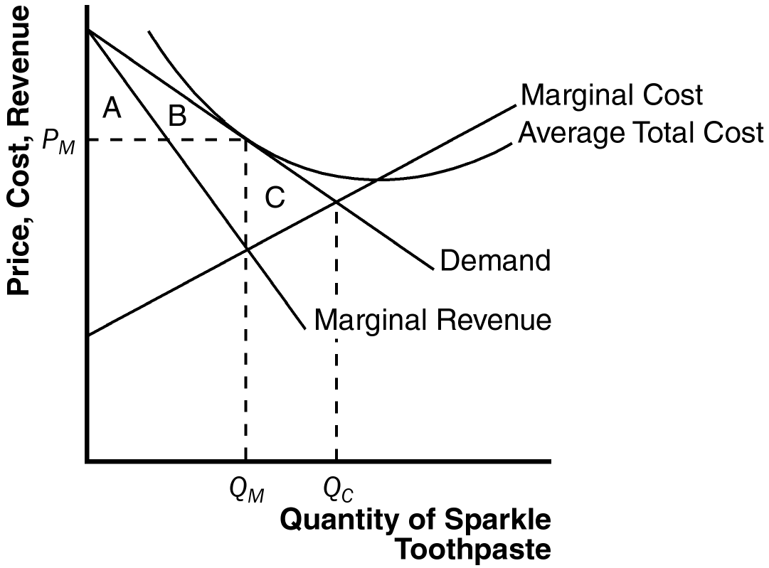

Figure 4

b. Sparkle's profit is zero, because at quantity Q_{M}, price equals average total cost.

c. The consumer surplus from the purchase of Sparkle toothpaste is areas A + B. The efficient level of output occurs where the demand curve intersects the marginal-cost curve, at Q_{C}. The deadweight loss is area C, the area above marginal cost and below demand, from Q_{M} to Q_{C}.

d. If the government forced Sparkle to produce the efficient level of output, the firm would lose money because average total cost would exceed price, so the firm would shut down. If that happened, Sparkle's customers would earn no consumer surplus.

7. a. As N rises, the demand for each firm’s product falls. As a result, each firm’s demand curve will shift in.

b. The firm will produce where MR = MC:

100/N – 2Q = 2Q
Q = 25/N

c. 25/N = 100/N – P

P = 75/N

d. Total revenue = P × Q = 75/N × 25/N = 1875/N²

Total cost = 50 + Q² = 50 + (25/N)² = 50 + 625/N²

Profit = 1875/N² – 625/N² – 50 = 1250/N² – 50

e. In the long run, profit will be zero. Thus:

1250/N² – 50 = 0

1250/N² = 50

N = 5

8. Figure 5 shows the cost, marginal revenue and demand curves for the firm under both conditions.

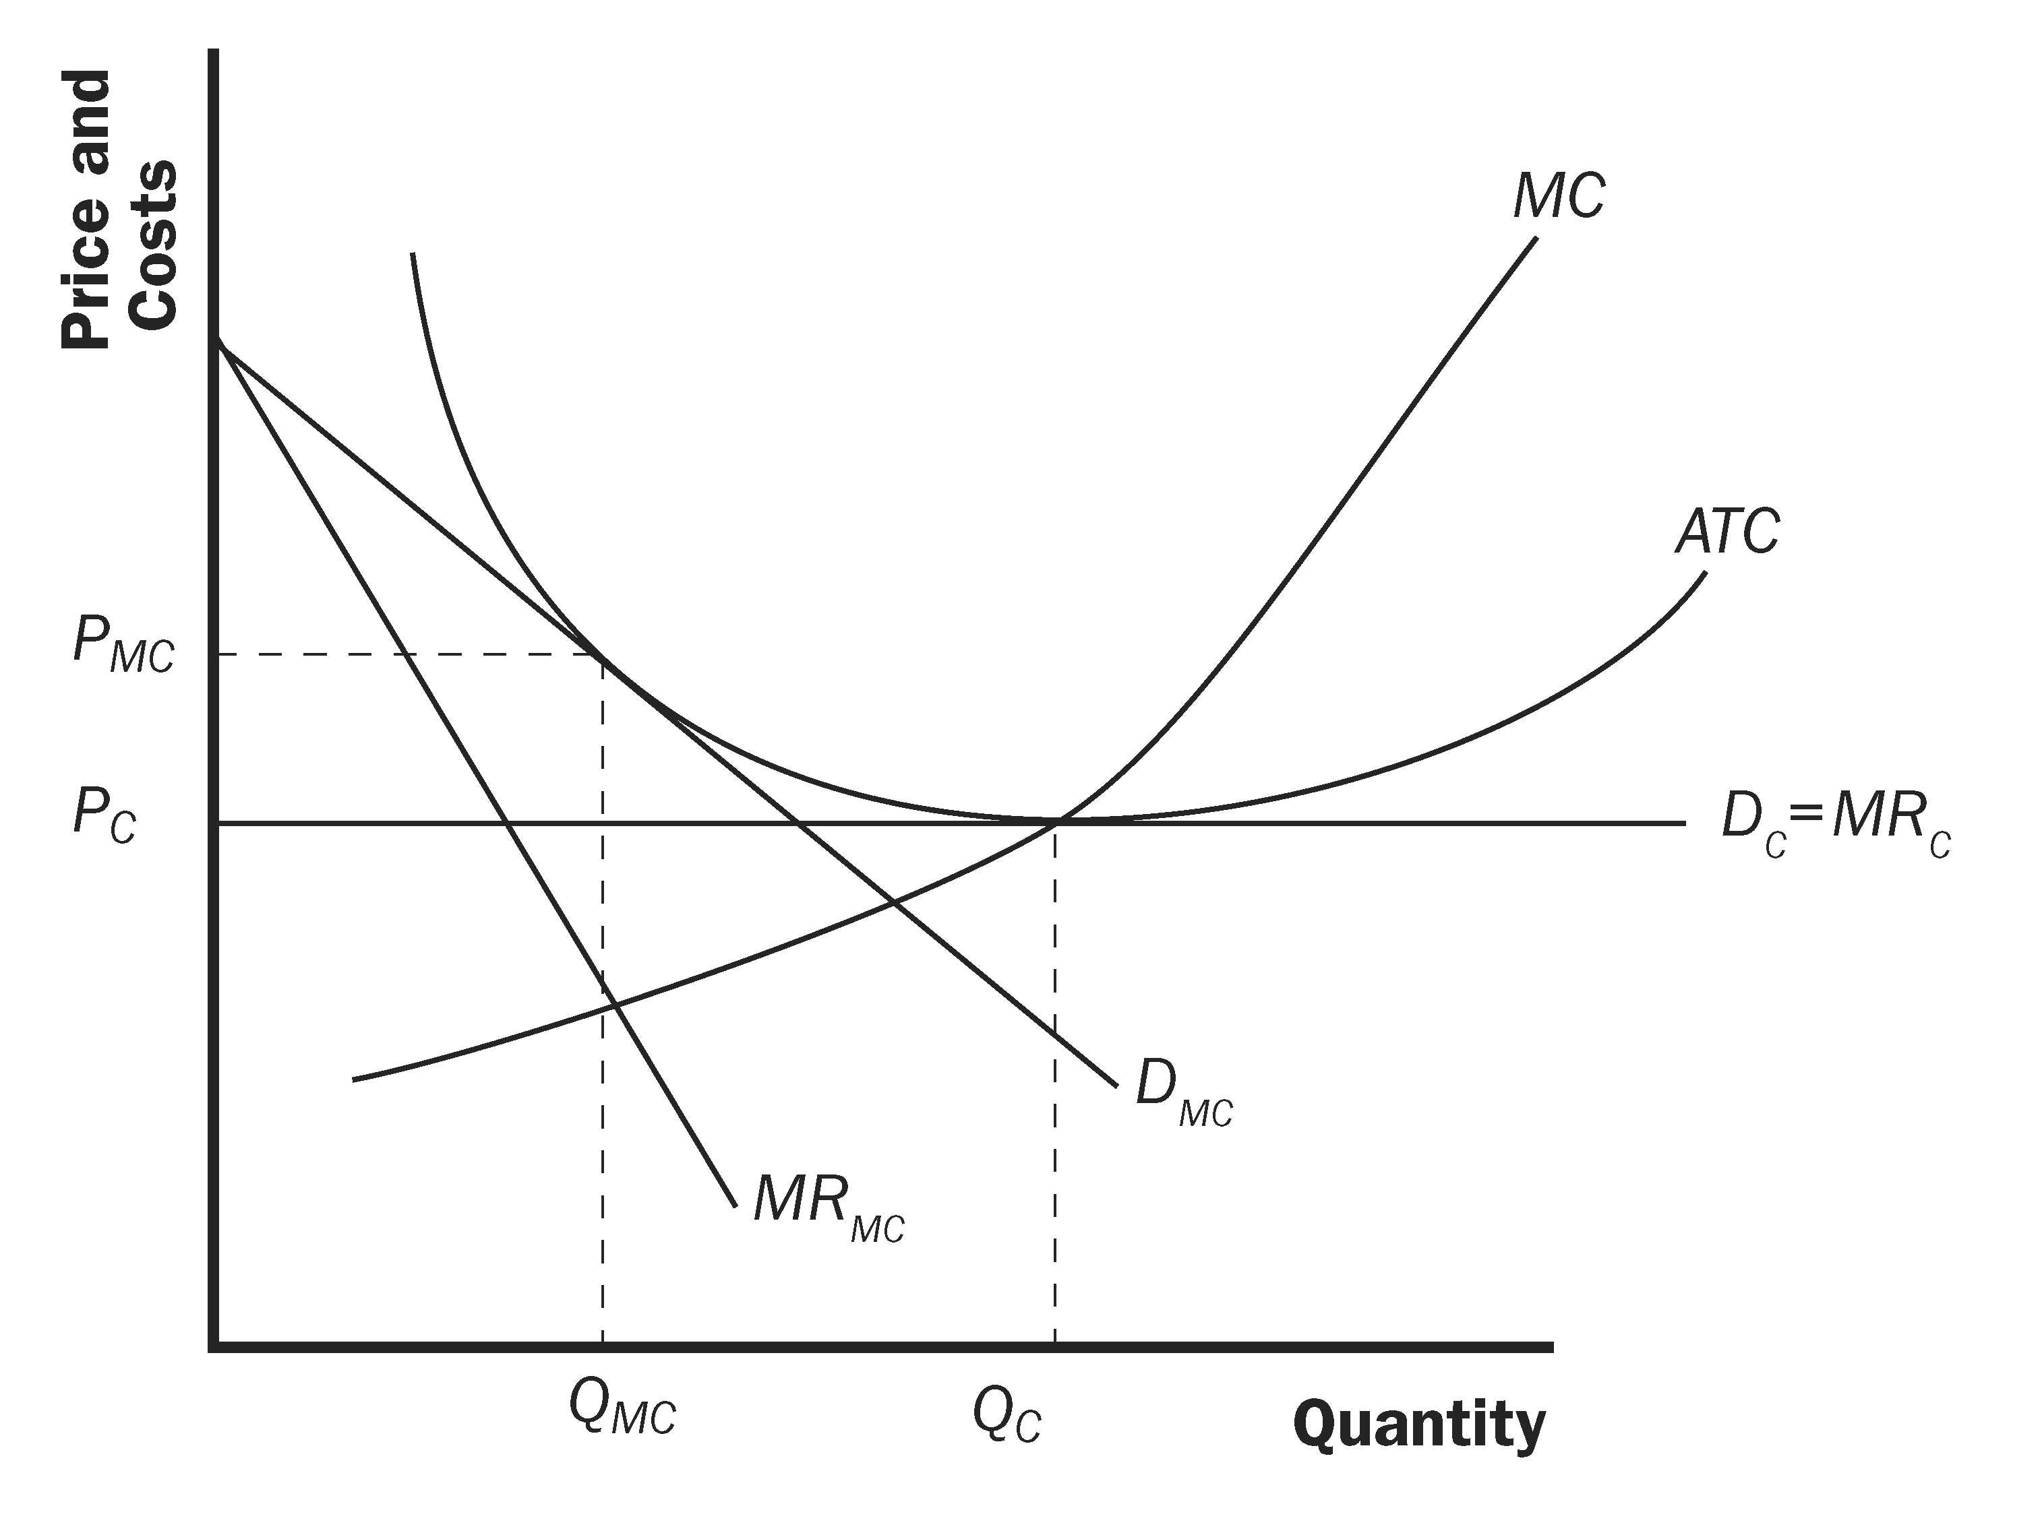
Figure 5

a. The price will fall from P_{MC} to the minimum average total cost (P_{C}) when the market becomes perfectly competitive.

b. The quantity produced by a typical firm will rise to Q_{C}, which is at the efficient scale of output.

c. Average total cost will fall as the firm increases its output to the efficient scale.

d. Marginal cost will rise as output rises. Marginal cost is now equal to price.

e. Profit will not change. In either case, the market will move to long-run equilibrium where all firms will earn zero economic profit.

9. a. A family-owned restaurant would be more likely to advertise than a family-owned farm because the output of the farm is sold in a perfectly competitive market, in which there is no reason to advertise, while the output of the restaurant is sold in a monopolistically competitive market.

b. A manufacturer of cars is more likely to advertise than a manufacturer of forklifts because there is little difference between different brands of industrial products like forklifts, while there are greater perceived differences between consumer products like cars. The possible return to advertising is greater in the case of cars than in the case of forklifts.

c. A company that invented a very comfortable razor is likely to advertise more than a company that invented a less comfortable razor that costs the same amount to make because the company with the very comfortable razor will get many repeat sales over time to cover the cost of the advertising, while the company with the less comfortable razor will not.

10. a. Figure 6 shows Sleek’s demand, marginal-revenue, marginal-cost, and average-total-cost curves. The firm will maximize profit at an output level of Q * and a price of P *. The shaded are shows the firm’s profits.

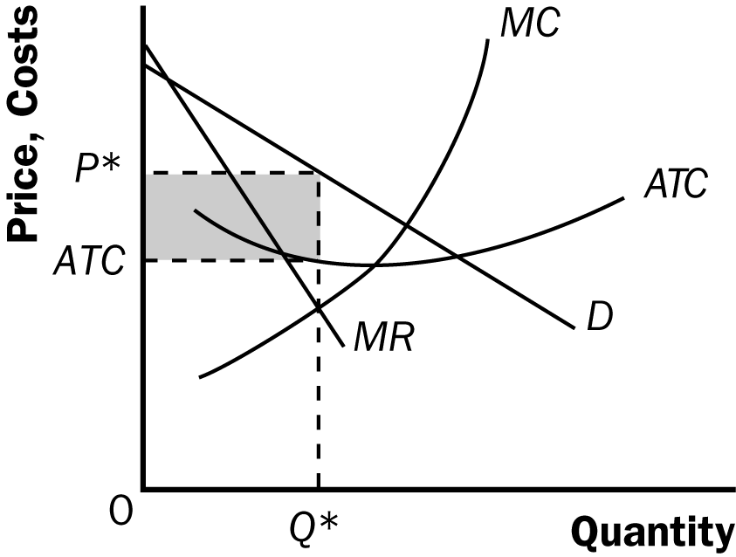

Figure 6

b. In the long run, firms will enter, shifting the demand for Sleek’s product to the left. Its price and output will fall. Firms will enter until profits are equal to zero (as shown in Figure 7).

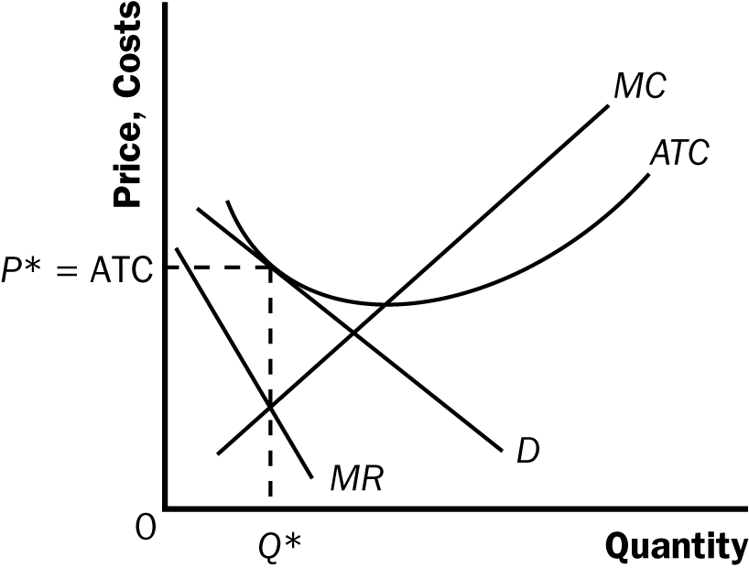

Figure 7

c. As consumers become more focused on the stylistic differences in brands, they will be less focused on price. This will make the demand for each firm’s products more price inelastic. The demand curves may become relatively steeper, allowing Sleek to charge a higher price. If these stylistic features cannot be copied, they may serve as a barrier to entry and allow Sleek to earn profit in the long run.

d. A firm in monopolistic competition produces where marginal revenue is greater than zero. This means that firm must be operating on the elastic portion of its demand curve.

11. a. Perdue created a brand name for chicken by advertising. By doing so, he was able to differentiate his product from other chicken, gaining market power.

b. Society gained to the extent that Perdue has a great incentive to maintain the quality of his chicken. Society lost to the extent that the market for chicken became less competitive, with the associated deadweight loss.

12. a. Figure 8 shows Tylenol's demand, marginal revenue, and marginal cost curves. Tylenol's price is P_{T}, its marginal cost is MC_{T}, and its markup over marginal cost is P_{T} − MC_{T}.

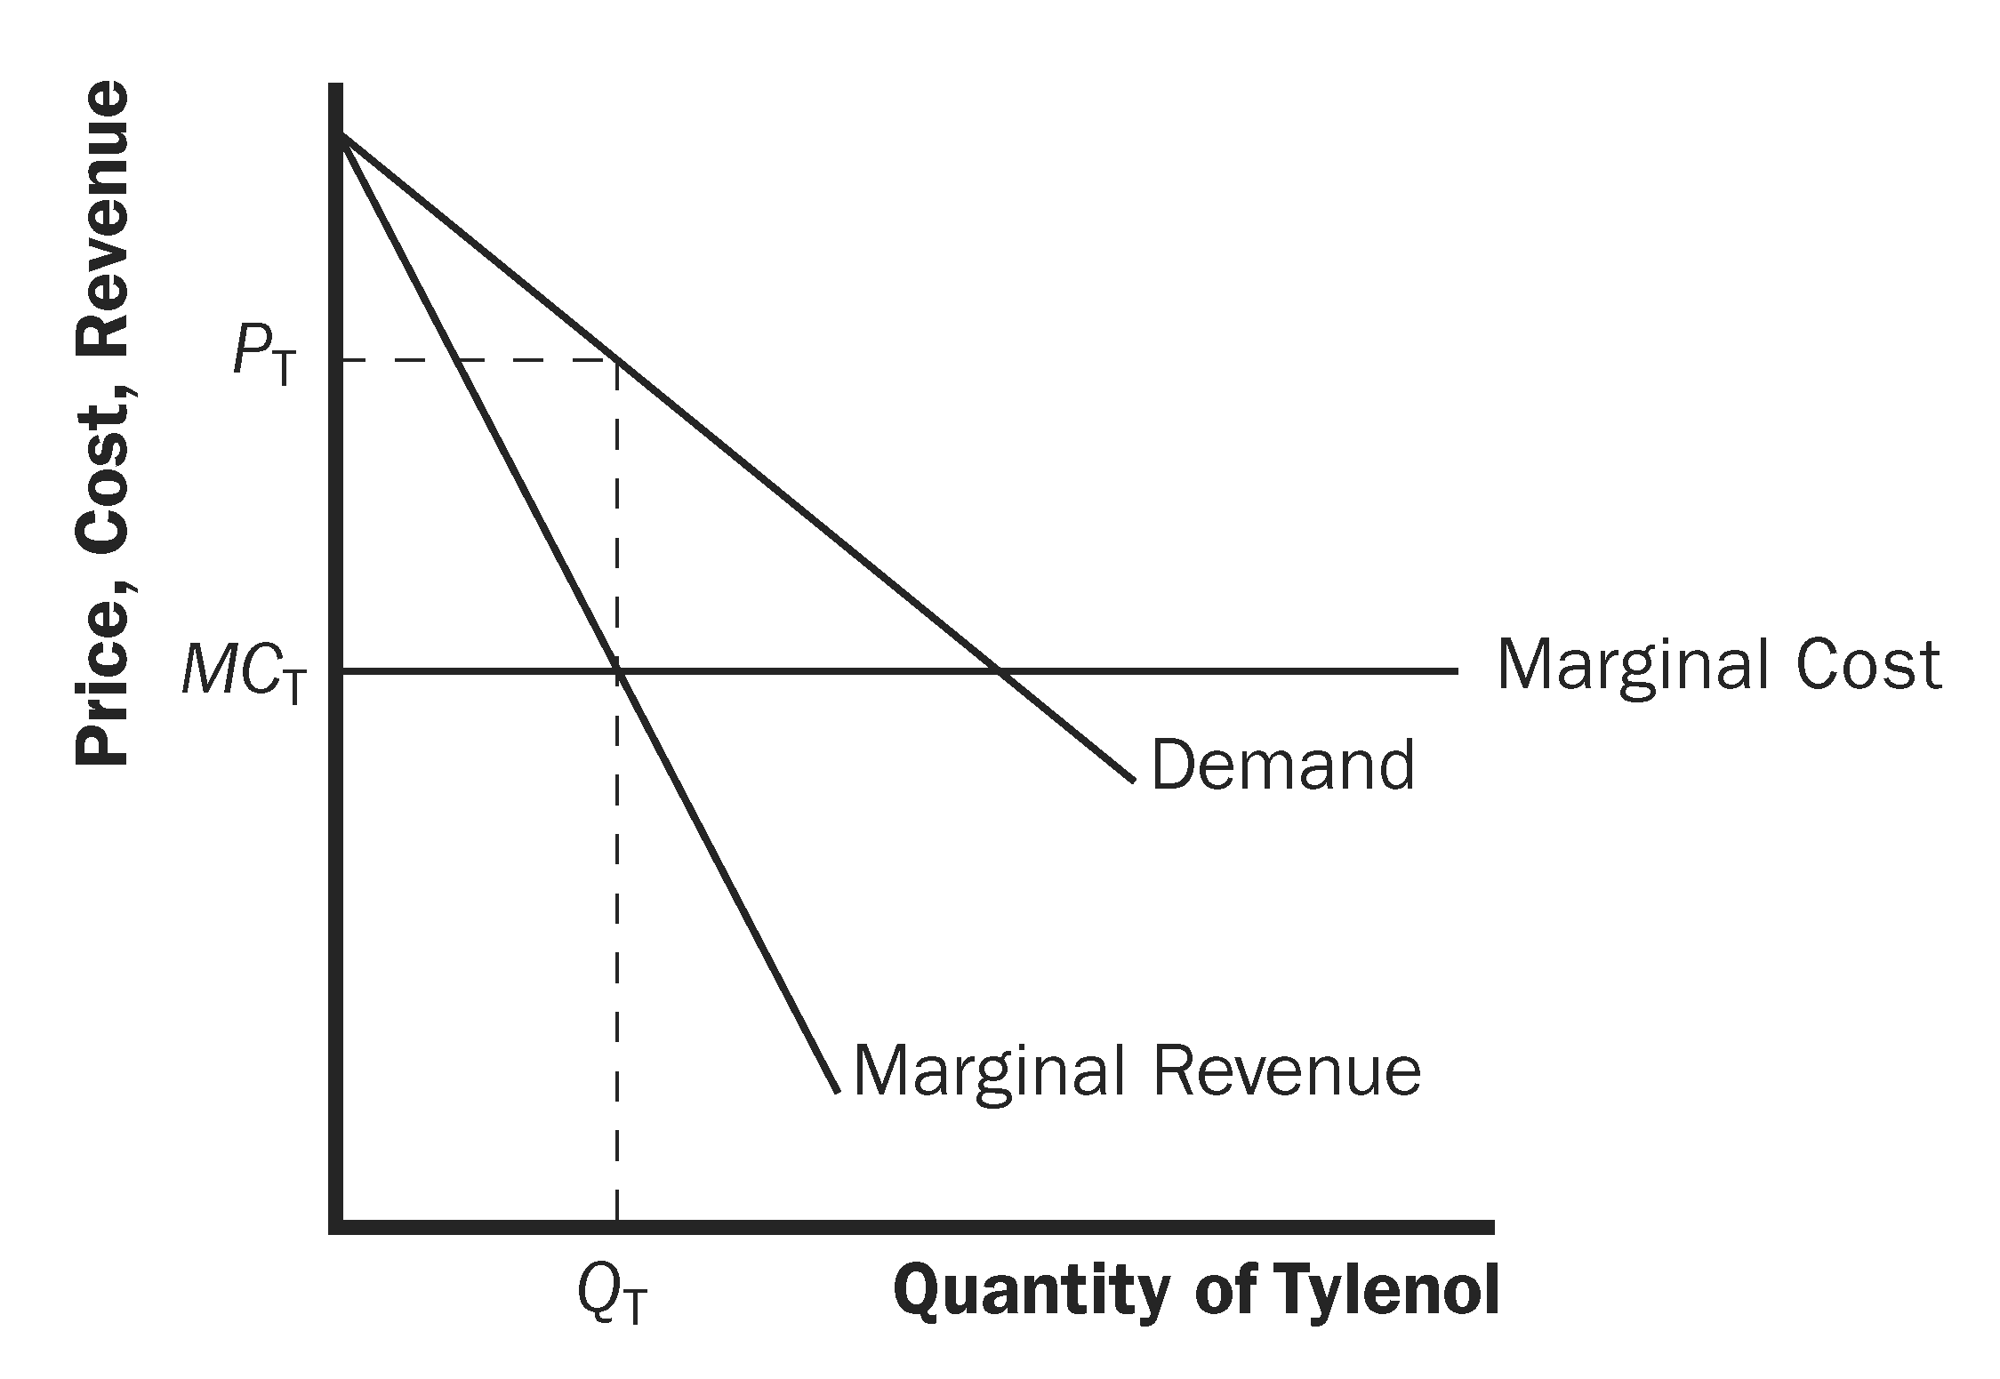

Figure 8

b. Figure 9 shows the demand, marginal revenue, and marginal cost curves for a maker of acetaminophen. The diagrams differ in that the acetaminophen maker faces a horizontal demand curve, while the maker of Tylenol faces a downward-sloping demand curve. The acetaminophen maker has no markup of price over marginal cost, while the maker of Tylenol has a positive markup, because it has some market power.

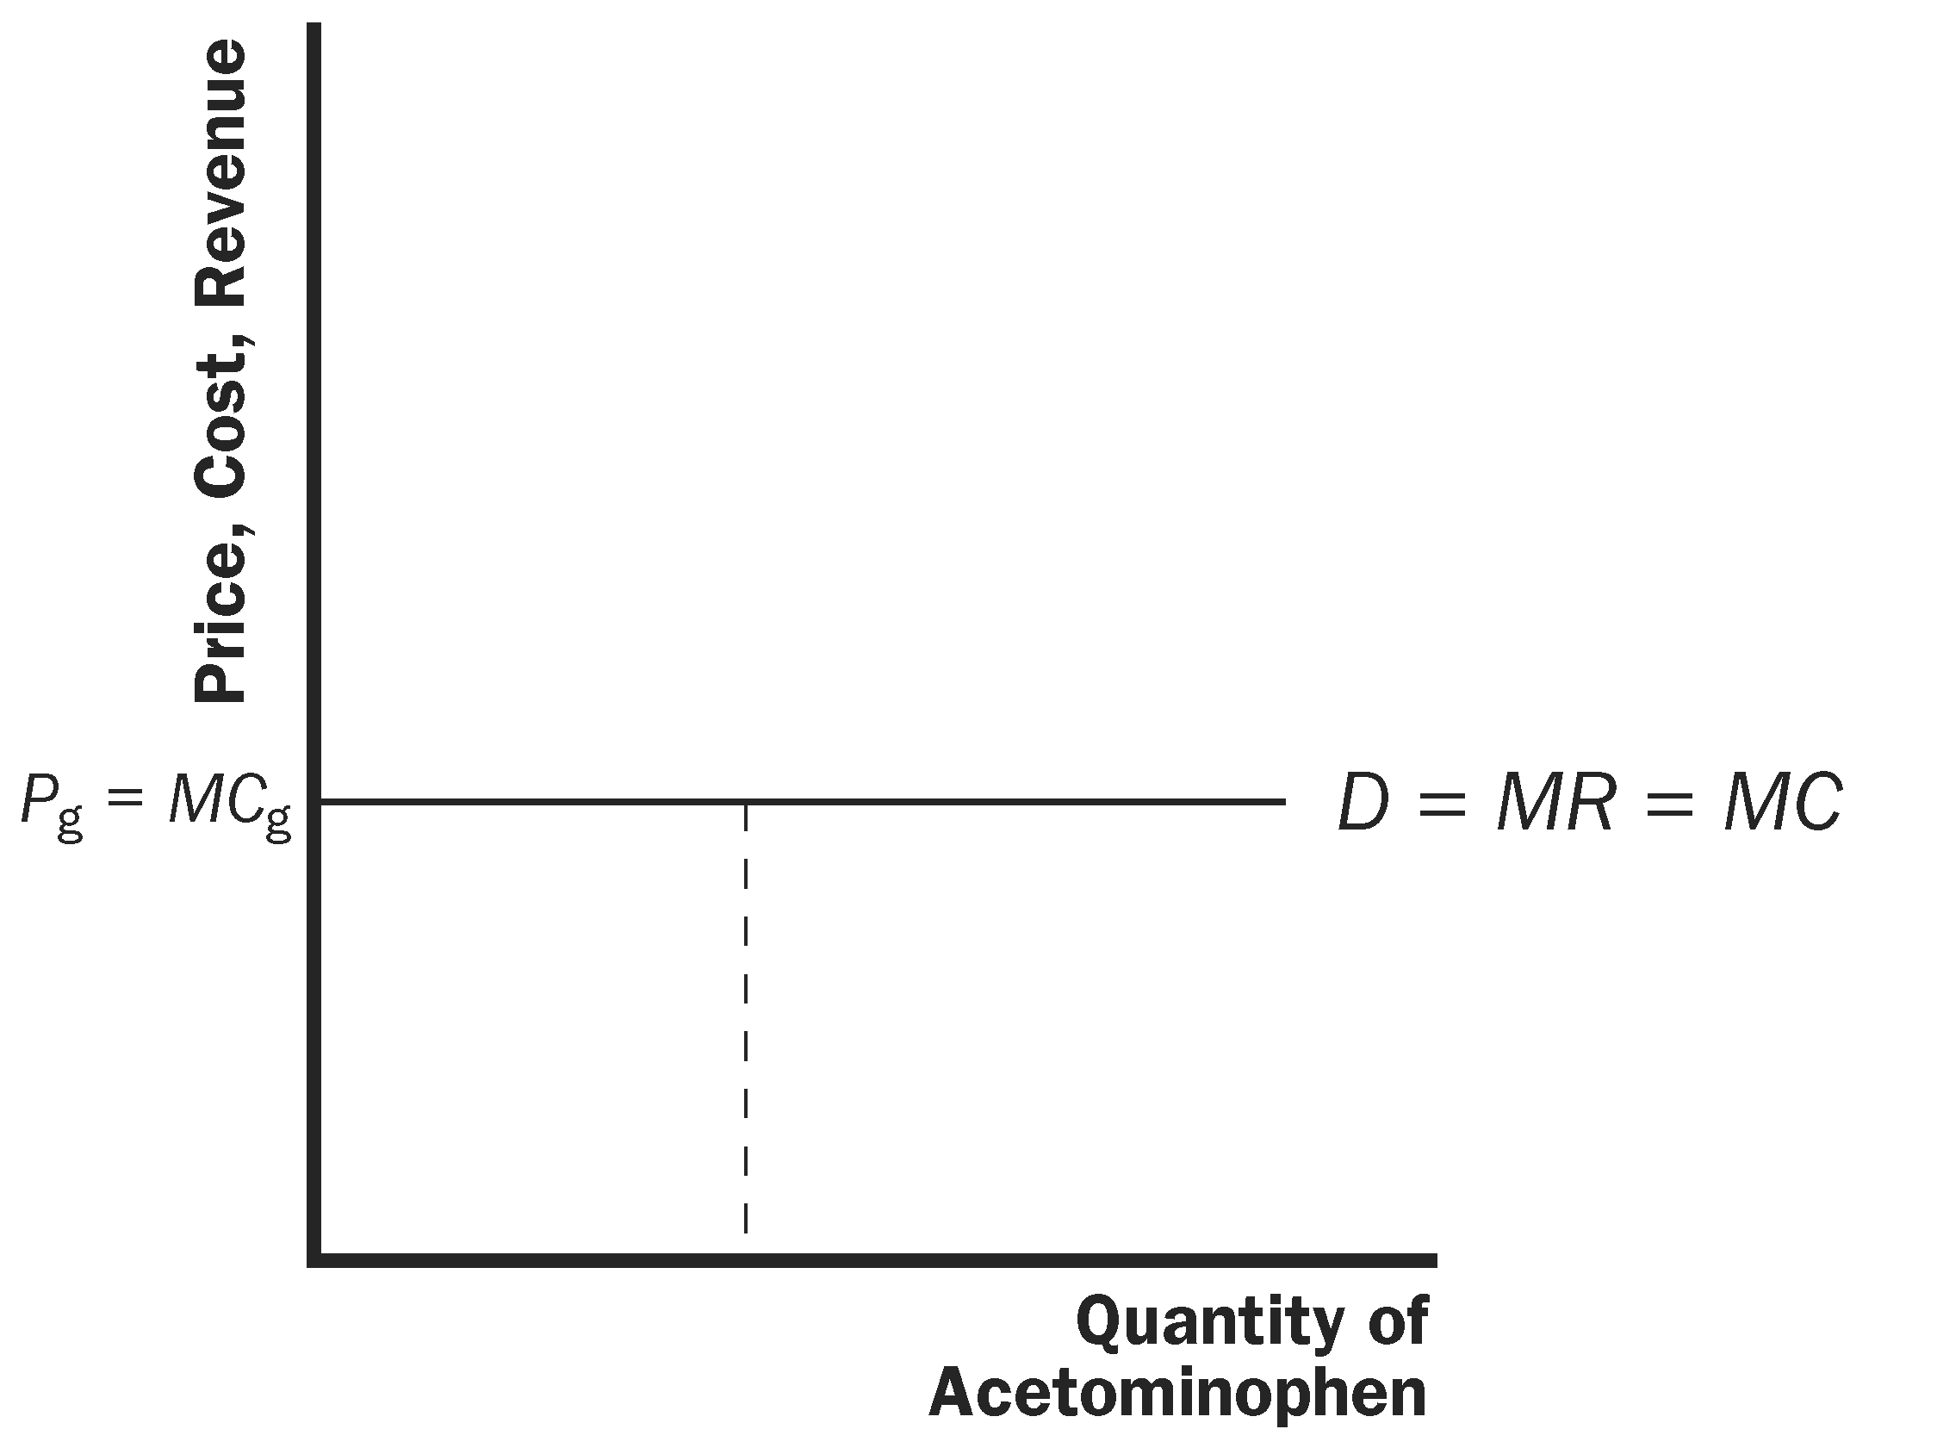

Figure 9

c. The maker of Tylenol has a bigger incentive for careful quality control, because if quality were poor, the value of its brand name would deteriorate, sales would decline, and its advertising would be worthless.

