Directions for Student Login to Online Textbooks
- Go to: https://www.stjohns.k12.fl.us/media/district-online-textbooks-k-5/
- Click on Envision Math 4th grade
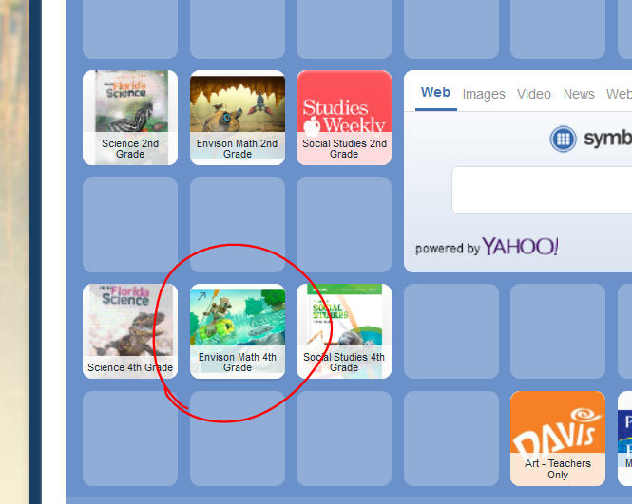

- Log-In with Student ID email address and password
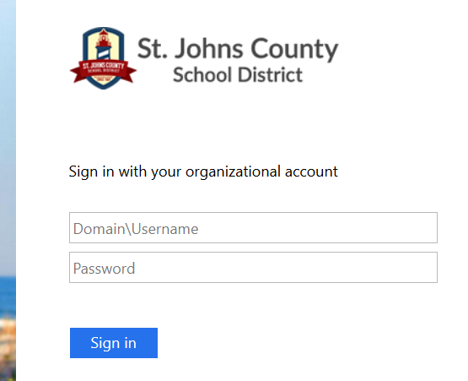
Example
Email: s + student number@stjohns.k12.fl.us s555555@stjohns.k12.fl.us
Password: noun + numbers giraffe123
Username: s + student number s555555

- Click on Pearson Realize
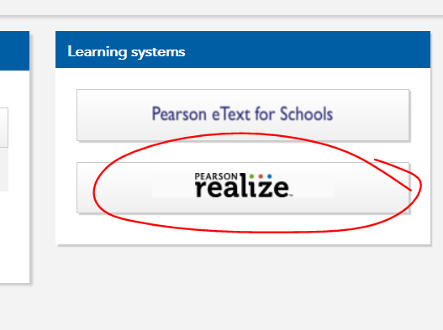

*Students should be familiar with this information and it should be in their planners. They also have account login cards from HAC. The S before their number stands for “student”. If they try to access a site and it asks for their username (not email address), just take off the @stjohns.k12.fl.us. This information will work for their Microsoft accounts so they may access Word, Excel, PowerPoint, etc. This is also their “clever” login.

*To access the Florida Science textbook, follow the same steps but click on the 4th grade Science Icon instead of the Envision Math.

*These district textbooks are also available by going to the following websites:
http://www-pvmkr.stjohns.k12.fl.us/links/ (school page)
http://teachers.stjohns.k12.fl.us/gerding-k/ (my page)

I hope this is helpful! Please don’t hesitate to contact me with any questions!

Thank you,
Mrs. Link

