Student Name: _______________

Assigned Password: math2010

Website Log-in Instructions
For Timez Attack

**If you’ve played Timez Attack on your home computer before, you must delete the icon on the desktop before you begin the instructions below.

1. Go to the website: www.bigbrainz.com/Schools.php

2. Select ‘Windows’ or ‘Mac


2b. Click on “run”
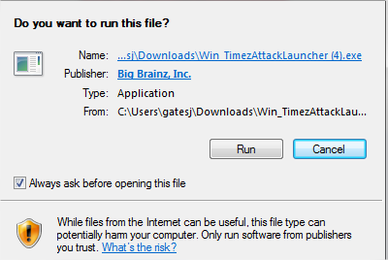

2c. Click on “Next”

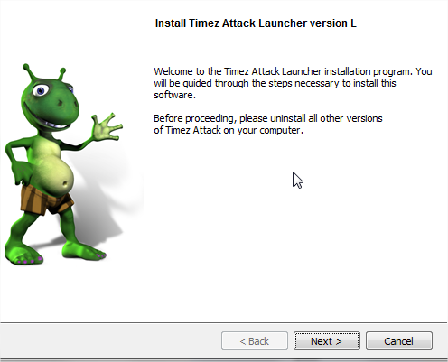
2d. Accept the agreement, then click “next.”
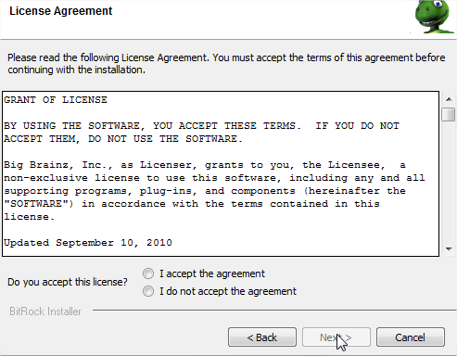

2e. Click “Finish” to complete installation.
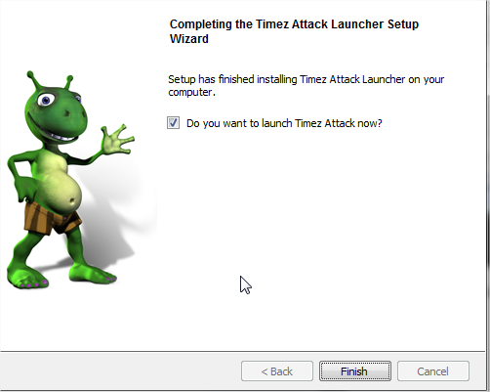

3. The following screen will appear. Click on the blue “School” icon.
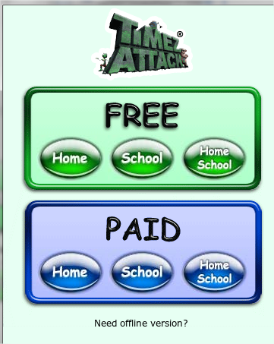
4. After it launches, select your state, district, and school.

5. Type in your assigned student password (math2010) in the blank field.

5. Under Troubleshooting in the upper left hand corner, hit ‘re-cache.’ Once it’s finished, just select the student’s class name and then their student name and hit play.

**If you encounter a problem accessing the website from home, please contact the Timez Attack company at 877-356-7040 or email kaysi@bigbrainz.com.

**If you encounter a problem with your password please contact your child’s teacher.

