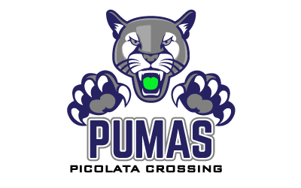 PLC Data Discussions
*Goal: Utilizing the most recent DRA data, develop targeted action plans for each group of students*
Teacher: ___________________________ Grade: ________
Students Who Are Currently On Level:
Students Who Are Currently Below Level:

DRA Focus for Instruction: *Targeted Instruction*
Oral Reading Fluency:
Students Who Scored in Instructional or Intervention Include:
Expression and Phrasing | Rate | Accuracy
Plan of Action for Each Area of Need:
Expression and Phrasing | Rate | Accuracy

DRA Focus for Instruction: *Targeted Instruction* Continued
Reading Comprehension
Students Who Scored in Instructional or Intervention Include:
Use of Text Features

Prediction

Summary

Literal Comprehension

Interpretation

Reflection

Plan of Action for Each Area of Need:
Use of Text Features

Prediction

Summary

Literal Comprehension

Interpretation

Reflection

